**May 2006**

**uuwvu. aloa.org**

**ELECTION**

**BALLOTS**

**INSIDE!**

**don’t miss...**

**MOSLER**

**JEWELERS**

**DILEMMA**

PLUS!

Forensics with Dan Cunningham,

Jim Hancock reuisits his hometown post Katrina, Claire Cohen asks Rre Vou a Professional? and More!

**\*\*\*\*\*\*\*\*\*\*\*\*\*\*\*5CW** 3_Q1GIT 303 Breck H. Ceimp CML *PO Box 47070* Atlanta GA 30362-0070

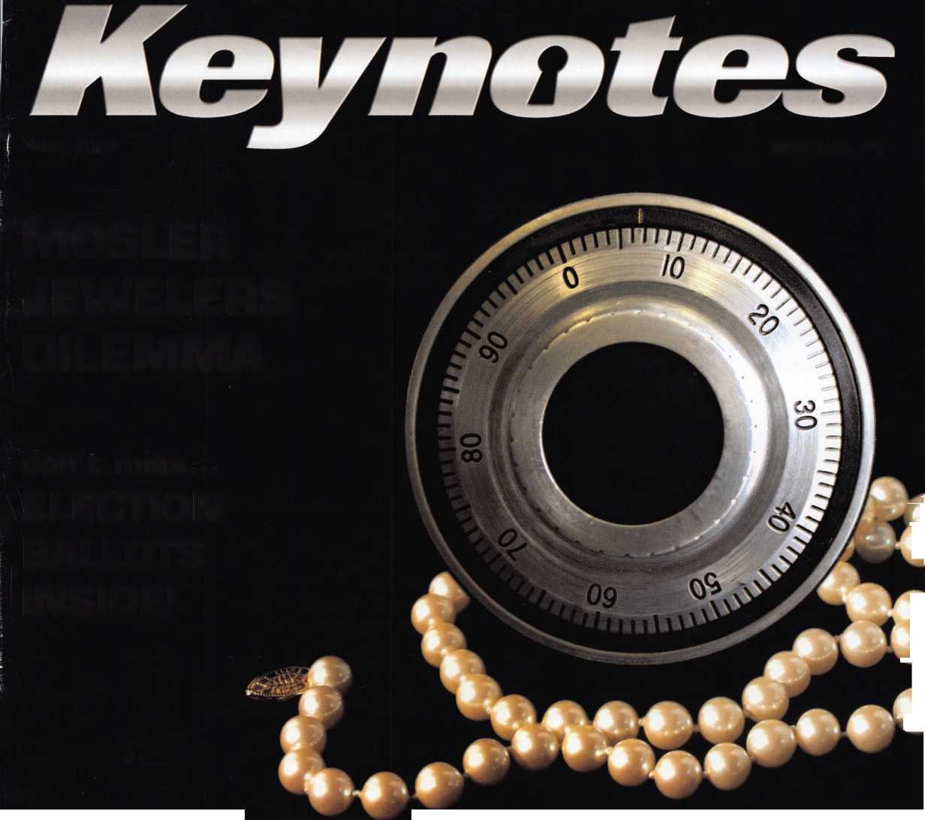

OUR STAND

IT’S QUITE POSSIBLY YOUR MOST

**TRUSTED SIDEKICK**

Keep it in Good Hands® with Allstate.



As a small business owner, there are few things you rely on more than your vehicle to keep you going. Your local Allstate agent can help protect it and your small business with services you need including

quick certificates of insurance, ID cards, assistance with the claims process, and more. All from one of the most widely recognized names in the business.

Are you in Good Hands®?

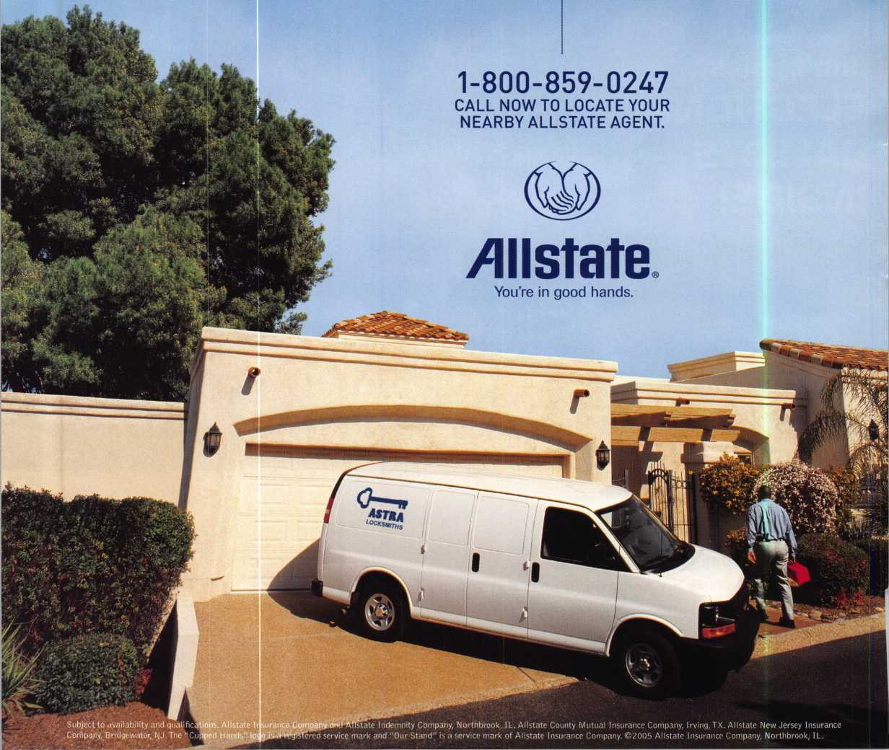

A Name You Know

As a business owner, you know the importance of a good name. Your name is your reputation. Your name stands for all that you offer in products and services. It’s a symbol of who you are. So, we thought you might like to know that Allstate, the name you know for insuring your personal vehicle and your home, also offers a business auto policy to help protect vehi­cles used in your locksmith business.

The following are coverages typically included in our business auto policy that might be important to you as a business owner:

Business Auto Liability coverage

* Higher limits up to $2,000,000 per occur­rence.
* Protects you if you are legally responsible for injuries and damages arising out of the ownership, maintenance, or use of business vehicles.
* Cost is based on several factors, including garage location, type and use of vehicle, and the violation and accident activity of your drivers.
* Additional Insured coverage may be required when you contract with govern­mental agencies or bid on local commercial jobs.
* Generally not available on a personal auto policy.
* Usually is no charge to add an insured to a Commercial Auto policy.

Hired Auto coverage

* Provides liability coverage for those vehicles you rent, hire or borrow for business use.
* The premium for hired auto liability coverage is based on the estimated annual rental cost.
* Tools and Special Equipment
* Provides protection to permanently attached equipment on your vehicle.
* You will need to let your agent know the value of the equipment to include in the cost of the vehicle.

You’re good at your business. Your insurance com­pany should be the same way.

Contact an Allstate agent to discuss your business auto insurance needs. To be referred to an agent, please call 800.859.0247 or email [abisO@allstate.com](mailto:abisO@allstate.com).

Subject to availability and qualifications. Insurance coverage is subject to policy terms.

Allstate Insurance Company

Allstate Indemnity Company Northbrook, IL

Allstate County Mutual Insurance Company Irving, TX

Allstate New Jersey Insurance Company Bridgewater, NJ

allstate.com

© 2005 Allstate Insurance Company, Northbrook, IL

DEMAND IT

4. m ■ * * ■Bwl|

Need information in a HurryP  
Use ALOA’s Fax On Demand service.

|  |  |  |  |
| --- | --- | --- | --- |
|  | J£k [_±) iJi) lSJ mK |  | w |
| Just call 310-575-5074 and receive: | | 13. | Safe & Vault Technicians Association Member |
| 1. | ALOA Index of Documents |  | Application/Subscription Form (2pg) |
| 2. | Becoming a Locksmith (lpg) | 14. | ALOA Chapter Roster (3pg) |
| 3. | Locksmith Career Summary (3pg) | 15. | Legislative Action Network (2pg) |
| 4. | Locksmith School List (2pg) | 16. | Legislative Action Network Newsletters (lpg) |
| 5. | ACE Class Schedule (8pg) | 17. | Various State Laws (lOpg) |
| 6. | Certification lnformation(3pg) | 18. | Industry Position Pager (lpg) |
| 7. | PRP Category List (lpg) | 19. | Current Legislative Action Network |
| 8. | ALOA Membership Application(2pg) |  | Newsletters (lpg) |
| 9. | ALOA List of Benefits (lpg) | 20. | Board of Directors Nomination Form (2pg) |
| 10. | Scholarship Application Form (lpg) | 21. | ALOA Convention Registration |
| 11. | ALOA Video Library Order Form (lpg) | 22. | ALOA Board Expense Reimbursement & |
| 12. | ALOA Membership Items Order Form (lpg) |  | Request Form |

AIOA continues to provide you with this and other great benefits and services!

310-515-5074

**You. Finger is th. »**

**Fingerprint Access Systei Standalone & Network**

2

a

<

(/)

D

>

O

■

5

5

5

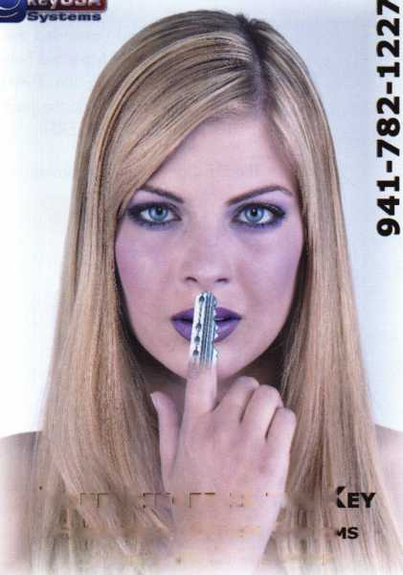

presidentia

viewpoint

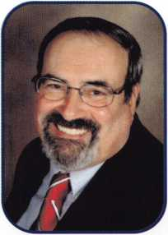

Dear Members,

I have just returned from meeting with the leaders of over a dozen different countries' locksmith associations  
at the European Locksmith Federation (ELF) Convention that was hosted by ERSI (The Italian Locksmiths' Asso-  
ciation) and held in Venice, Italy. I have been attending these shows for almost twenty years and this con-  
vention was a good one. There was a wealth of education presented by educators from seven different coun-  
tries. The trade show was very informative. The Gala Dinner was top notch, and most important was that  
our fellow security specialists remained at all the events and eagerly exchanged ideas and information. It  
was an uplifting experience and lucky for me that the official language of ELF is English!

ELF's President, Dave O'Toole, had invited me to attend ELF's Board Meeting. At the meeting there were many  
concerns voiced about our industry's manufacturers selling direct to the public and the duplication of patent-  
ed keys. (Does any of this sound familiar in your part of the world? I reiterate-Global economy, we all must  
take interest and be a part.) Previous to the Board Meeting, Dave O'Toole and I had a meeting with Ake  
Sund, Senior Vice-President of ASSA Abloy to discuss the afore mentioned concerns. Mr. Sund addressed  
the assembled leaders to explain his company's stance on these matters. The ELF Board took the opportuni-  
ty to elect a new First Vice-President, Hans Adema of Holland. Also, the locations of the next three conven-  
tions were announced: Riga, Latvia - 2007, Athens, Greece - 2008, and Warsaw, Poland - 2009.

At the convention I was fortunate enough to meet with the President of the National Mexican Locksmith Asso­ciation. We discussed having another joint education event in Mexico City in the near future.

Of course, our ALOA booth was up and running at the convention show manned by our European Director, Hans Mejlshede and me. We spoke with many members and handed out information about membership and our 50th Anniversary Convention in Las Vegas. The giving away of the 1956 T-Bird stirred up a lot of interest.

My wife, Dee, and I attended the Gala Dinner. Here I had the opportunity to present both Dave OToole, President of Elf, and Maurizio Benini, President of ERSI, engraved gavels from ALOA as tokens of our meet­ing and mutual cooperation. Then to my total surprise, Dario Casiroghi, convention chairman and past pres­ident of ERSI called me to the podium and presented me with a beautifully hand crafted key and made me an honorary member of ERSI.

The ELF Convention has proven a great opportunity for our association. Well for now, Arrivederci.

Take 'er easy!

Sincerely,

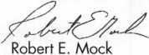

Keynotes • May 2006

**WEISER LOCK**

*TOOLS*

*^ mm m*

***Why Do  
Locksmiths  
Everywhere Buy  
Supplies at***

***H.L.Fiake?***

*He Extremely Competitive  
He E/Z Free Freight Minimums*

*He Service with a Smile  
He High Fill Rate*

*He Hard to Find Items*

*He E/Z Order Web Site*

***[WWW.HlHAKC.com](http://WWW.HlHAKC.com)***

* *Order 24 hours a day*
* *Updated Every Business Day*
* *Extra Discount for Web Orders*
* *Personalized Inventory Lists*

5CHLAGE

**VON DUPRIN**

*LOG ON TO...*

[www.HiFUKC](http://www.HiFUKC). com

*MUTOmmt 'Hr*

*’ HUH If **LOCKCRAFT^j**©ASP) **HATA**

*DETERMINATOR MAJO*

***VISA***

*ACCESS C0HTR01*

**LOCKS**

<§M

COBRA

STRATTEC

*Wed#&c&\**

|  |  |  |  |
| --- | --- | --- | --- |
|  | lJEIEX | ROFUSftn |  |
| DOR-O-MttlC h | cs W«kI» | 3R |

WCito *6696

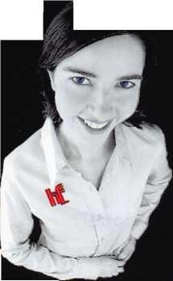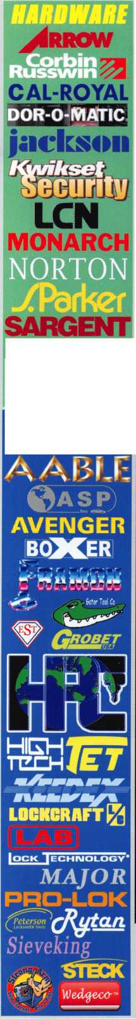

f

a

t

u

ELECTION BALLOTS 2006

Mosler Jewelers

Find out what happened when Greg Perry was asked to take a look at a Mosler safe that hadn't been serviced in over 1 2 years.

by Greg Perry, CML, CPS

The Lock Speaks

Dan Cunningham takes you inside forensic locksmithing to prove or disprove forcible entry on an insurance claim.

by Dan Cunningham,, JD, CRL, CFL, CFATE

**AD INDEX**

**Allstate Inside Front Cover**

**Fax on Demand 1**

**E-Key 1**

**HL Flake 3**

**ALOA 2006 7**

**Powermate 15**

**INKAS 17**

**Clearstar 21**

I Got It All Ready For You

Basic Locksmith Work - $ 1 0 If you watch - $ 15 If you talk while I'm working - $ 20 If you worked on it first- $ 50

by Thomas Stern

Journey Home

In August 2005 FHurricane Katrina had taken dead aim at Gulfport Mississippi causing great damage and tragic loss. Jim Fiancock takes us to his beloved hometown that he once knew and loved.

by Jim Hancock

Are You A Professional?

Read on to find out what it really means to be a professional, at any level.

by Claire Coheni, CML

**GARDALL 29**

**Bianchi 31**

**Safetech 2007 33**

**Jameson Code 35**

**Payment Retriever 42**

**Turn 10 42**

**A&B Safe 42**

**Ultralift 43**

**Service Magic 43**

**Compx Inside Back Cover**

**FKI Back Cover**

**Departments**

Presidential Executive 5 Calendar 8 Classified 36 Legislative 40

Viewpoint 2 Applicants 6 Core 9 Associate

Members 38

Visit our NEW website at [www.aloa.org](http://www.aloa.org)

e x e c u

**five**

Volume 52, Issue 5



Additional contact information for the ALOA Board and most Keynotes authors is  
available through "Locksmith Search" on the ALOA Web site- [www.aloa.org](http://www.aloa.org) or by  
contacting the ALOA office at 3500 Easy Street; Dallas, TX 75247; (800)532-2562;  
FAX (214)819-9736; e-mail [aloa@aloa.org](mailto:aloa@aloa.org).

Editor

Betty Henderson [betty@aloa.org](mailto:betty@aloa.org)

Advertising Sales

Kim Hammond voice: 817-645-6778

Fax: 817-645-7599 e-mail: [adsales@aloa.org](mailto:adsales@aloa.org)

Executive Director

Charles W. Gibson, Jr., CAE [charlie@aloa.org](mailto:charlie@aloa.org)

Associate Executive Director

David Lowell, CML, CMST [david@aloa.org](mailto:david@aloa.org)

Convention & Meetings Manager

Jo Anne Mims [joanne@aloa.org](mailto:joanne@aloa.org)

Operations/Membership Manager

Mary May [mary@aloa.org](mailto:mary@aloa.org)

Director of Creative Services

Betty Henderson [betty@aloa.org](mailto:betty@aloa.org)

IT Operations Manager

Greg Jackson [greg@aloa.org](mailto:greg@aloa.org)

Comptroller Kathy J. Romo

Membership Coordinator Shelly Jett

Convention & Meetings Assistant Karen Lyons

PRP/Education Coordinator Mayra Ocon

Mail Room Coordinator Kevin Wesley

Creative Media Specialist Margarita Garza

Accounting Coordinator Joyce Nixon

Executive Assistant Sue Langford

Assistant Education Manager Bob Stafford

Legislation Manager Tim McMullen

Receptionist Shelley Melton

Contributors

Jerome Andrews, CML  
Paul Chandler, CRL  
Claire Cohen, CML  
Brian Costley, CML, CMST  
Eric Costley, CRL

Ray D'Adamo, CML Billy Edwards, CML Dan Graffeo, CRL,CMST Jim Hancock, CPL Jeff Nunberg, CML, CMST

Randy Simpson, CML, CPP Robert Stafford, CML Dave Thielen, CML Greg Perry, CML,CPS

Tom Seroogy

Charles Stephenson, CPS

Dennis Watanabe, CML, CMST

Mission Statement: The Associated Locksmiths of America, Inc. is dedicated to enhancing the professionalism, education and ethics among  
locksmiths and those in related sectors of the physical security industry. With approximately 10,000 members in the United States, Canada and the  
freeworld, ALOA is poised to help members obtain the knowledge, the strength, and the confidence to perform their role in the physical security field  
with pride and dignity. But it is only through active involvement and participation that ALOA can fully achieve its potential—and can help members to  
achieve theirs.

Policies: Keynotes® is the official publication of the Associated Locksmiths of America, Inc. (ALOA). Keynotes® acts as a moderator without approving,  
disapproving, or guaranteeing the validity or accuracy of any data, claim, or opinion appearing under a byline or obtained or quoted from an acknowl-  
edged source. The opinions expressed by the authors do not necessarily reflect the official views of ALOA. Also, appearance of advertisements and  
new products or service information does not constitute an endorsement of products or services featured by the Association. The Association does not  
accept responsibility for the inaccuracy of any data, claim, or opinion appearing in this publication, due to typographical errors on the part of the  
authors, Association staff or its agents.

Editor's Note: This publication is designed to provide accurate and authoritative information in regard to the subject matter covered. It is provided  
and disseminated with the understanding that the publisher is not engaged in rendering legal or other professional services. If legal advice and other  
expert assistance is required, the services of a competent professional should be sought.

Authors' Payment: Payment for eligible submissions to Keynotes will be based on the following criteria: topic, time spent and past contributions. Authors who  
regularly submit to Keynotes® are generally paid a higher rate. The latter is especially true of authors who write to fit specific editorial needs and submit said copy  
by Keynotes® deadlines. As a general guideline: Average payment for a 750 word, business or light' technical article would be $200. Payment for a 1500 word  
article involving significantly higher time and research efforts would be $400.

Payment will not be offered for articles submitted by ALOA employees or members of the ALOA Board of Directors (unless material is of a technical  
nature), nor for articles submitted by a company that promote that company's products or services. ALOA reserves the right not to pay for articles sub-  
mitted by an individual(s) that promote a particular company's products or services.

Disclaimer: The Associated Locksmiths of America, Inc., (ALOA), reserves the right to refuse any article for any reason. Additionally, ALOA reserves  
the right to edit, amend or modify any article submitted for publication in order to preserve technical accuracy, clarity, fairness or grammatical cor-  
rectness. ALOA will make the best efforts to notify the author of any changes. The extent of ALOA's liability for any article or information contained  
therein will be a notice of correction or retraction in the next possible issue.

Keynotes'9 (ISSN 0277 0792) is published monthly except for the combined June/July issue by The Associated Locksmiths of America, Inc.,  
3500 Easy St., Dallas, TX 75247-6416. Telephone: (214) 819-9733; FAX (214) 819-9736; e-mail [aloa@aloa.org](mailto:aloa@aloa.org). Subscription rates for  
members—$ 15.00 per year. Periodical class postage paid at Dallas, Texas. POSTMASTER: Send address changes to: Keynotes, 3500 Easy St., Dallas,  
TX 75247-6416. © Copyright 2003, All rights reserved. No part of the contents may be reproduced or reprinted in any form without prior  
written permission of the publisher.

President

Robert Mock (856) 8630710 [president@aloa.org](mailto:president@aloa.org)

Secretary

John Soderland, CML, CMST  
(414) 327-5625

[secretary@aloa.org](mailto:secretary@aloa.org)

Directors, Northeast

Peter Sarailian, CRL  
(201) 944-7547  
[nedirector@aloa.org](mailto:nedirector@aloa.org)

Vernon Kelley, CPL  
(609) 771-3126  
[nedirector@aloa.org](mailto:nedirector@aloa.org)

Directors, Southeast

Tom Gillingham, Jr., CML, CPS  
(615) 2640747  
[sedirector@aloa.org](mailto:sedirector@aloa.org)

Ken Kupferman, CML  
(813) 961-5784  
sedirector@aloa .org

Director, North Central

William Smith, RL  
(920) 893-5282

Guy Spinello, RL  
(815) 394-1000  
[ncdirector@aloa.org](mailto:ncdirector@aloa.org)

Director, South Central

CD Lipscomb, CML, CPS  
(903) 874-3522  
[scdirector@aloa.org](mailto:scdirector@aloa.org)

Directors, Southwest

Gordon R. Racine, CML  
(719) 384-4707  
swdirector@aloa. org

Julie McCluney, CRL  
(714) 636-5652  
[swdirector@aloa.org](mailto:swdirector@aloa.org)

Director, Northwest

Jim Jeffries, CPS  
(877) 241-6978  
[nwdirectOf@aloa.org](mailto:nwdirectOf@aloa.org)

Director, European

Hans Mejlshede, CML  
(453) 539-3939  
eurd irector@aloa. org

Director, Asian

JoeJ. Lee, CRL  
(215) 289-2404  
[asiandirector@aloa.org](mailto:asiandirector@aloa.org)

Director, Associate

Paul M. Justen  
(612)238-4646  
[asdirector@aloa.org](mailto:asdirector@aloa.org)

Trustees

[trustees@aloa.org](mailto:trustees@aloa.org)

Randy Simpson, CML  
(281) 240-5959

JohnJ. Greenan, CML, CPS  
(773) 486.2030

William Young, CML, CPS  
(610) 647-5042

Past Presidents

2003-2005 William Young, CML, CPS 2001-2003 Randy Simpson, CML 1999-2001 John Greenan, CML, CPS 1997-1999 Dallas C. Brooks 1995-1997 David Lowell, CML, CMST 1993-1995 Breck Camp, CML 1991-1993 Henry Printz, CML 1989-1991 Evelyn Wersonick, CML, CPS 1987-1989 Leonard Passareilo, CPL 1985-1987 Joe Jackman, CML 1983-1985 Stanley Haney, CPL 1981-1983 Louis LaGreco, CPL 1979-1981 John Kerr, RL j 1977-1979 Clifford Cox, CML 1974-1977 Charles Hetherington ■ 1972-1974 Gene Laughridge 1970-1972 William Dutcher, RL 1968-1970 Constant Maffey, RL 1966-1968 Harold Edelstein, RL 1964-1966 William Meacham 1962-1964 Robert Rackliffe, CPL 1960-1962 Edwin Toepfer, RL 1956-1960 Ernest Johannesen



Keynotes • May 2006

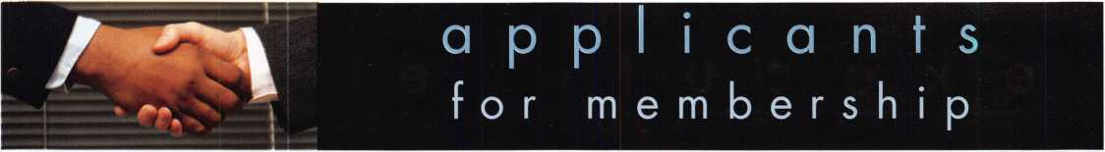

AZ

Yuma

Don R. Williams Thomas E. Wilson

Sponsor: Leon P. Burge CML

Christopher D. Badilla

Sponsor: Leon P. Burge CML

CA

Blue Jay

Greg Seecof

Gardena

Phil Holmes

Sponsor: Michael D. Sigmund Lakeside

Charles Stevens

Sponsor: Thomas J. Newton Jr, CML, CPS Poway

Alan Morran

Sponsor: Thomas M. McClure Santa Barbara

Thomas M. McClure

Santa Rosa

Angelo Pioli Jr

Sponsor: Larry V. Wirth

CO

Golden

Brent Dickman

CT

Waterbury

Reshat Hasankolli

FL

Crystal River

Douglas W. O'Connell

Sponsor: Randall L. Boyer CML, CPS Estero

Raymond R. Ackerman III

Fort Myers

Marco Dano James Cail

Newberry

Kevin P. Hamilton

Sponsor: Ralph Hamilton

ID

Idaho Falls

Darin Ritchie

Sponsor: Melvin L. Brown CRL

Meridian

Steve Weber

IL

Arlington Heights

Gary T. Nunes

Sponsor: Alan N. Thomas

IN

Indianapolis

Wesley W. Murphy

Sponsor: Phillip D. Squibb Portland

Robert Byers Jr

Sponsor: Jim Williams CRL



Percy J. Price II

Sponsor: Clifford D. Lipscomb CML, CPS Slidell

Glynn E. Hinton

Sponsor: William J. Smith RL

Steven J. Lemoine

Sponsor: William J. Smith RL Vidalia

Glen A. Sawyer CRL

Sponsor: Clifford D. Lipscomb CML, CPS

MA

Salem

Andrew M. Harlow-Powell

Sponsor: David A/I. Troiano

Imp

Easton

Justin T. Davis

Ml

Belleville

Joshua Winekoff

Coldwater

James W. Beckmeyer

Novi

John A. Thomson

NJ

Parsippany

Alfred Figueroa

Sponsor: Peter Sarailian CRL Phillipsburg

William Timmann CML

Sponsor: Peter Sarailian CRL

NM

Albuquerque

Peter M. Grady Las Cruces

Roel Guerra Ray G. Holguin

NV

Las Vegas

Micheal W. Alamo

Sponsor: Richard J. Calabrese

Bay Shore

David Sobel

Sponsor: Alan J. Sobel Buffalo

Sam J. Terranova

Conesus

Glenn E. Miller

Garden City

Joseph Allocco

Sponsor: Michael P. Bach Williston Park

Gary Sofferman

Sponsor: Joel S. Kramer

OH

Brook Park

Kenneth Wayne CML

OK

Bixby

Eric M. Jamison

Sponsor: John J. Ruperd Tulsa

Chris Slaton

Sponsor: Robert T. Hagen

PR

Mayaguez

Karla A. Ortiz Rodriguez

Sponsor: Carlos Ortiz

*SC*

Charleston

Steven K. Jantzen

Sponsor: Billy E. Fowler North Augusta

Stephan D. Stanley

TX

Gran bury

Rick O'Neill

Sponsor: Shane M. Varney CRL, CPS Houston

David Howe

Sponsor: Shane A/I. Varney CRL, CPS Midland

Johnnye H. Proctor CRL

VA

Bristol

Roger Phelps

Sponsor Mark A Fields CRL Manassas

Kevin C. Rychlik

Bahamas

Nassau

Solomon Knowles

Sponsor. TrworB. Fox



Winnipeg

Dale K. Rutherford CRL

Sponsor Richard B. Winzinowidi CRL

ON

Elmvale

Domenic Mucci

Sponsor Peter Sarailian CRL Owen Sound

Erie Schofieris

Sponsor Peter Sarailian CRL



Haywards Heath

Daniel Page

England

Middlesex

Jason Dorner

Japan

Narita Cty Chiba Ke

Toshihiro Asano

AP

FPO

James Cherry

Sponsor Joseph £ CorlieCMbCPS

Scotland

Paisley Glasgow

Raymond Bradley

Sponsor Graeme Robertson

These applicants are scheduled for clearance as members of ALOA. The names are published for member review and comment within 30 days of this Keynotes issue date, respectively, to ensure  
applicants meet standards of ALOAs Code of Ethics. Protests, if any, should be addressed to the Membership Department and must be signed. Active Membership applicants (a) have worked in  
the industry two or more years. Allied Membership (AL) applicants are not locksmiths, but work in a security-related field. Apprentice Membership (AP) applicants have worked in the industry less than two years.



Keynotes • May 2006

f

sponsored by:

FKI /|H Security & Safely Q)/TOC

SECURITY GROUP PlWM SMVCC. **PllW** SOtltiOflS. **SECURITY PRODUCTS**

Classic *1956* Tkunderbirdl

One Lucky Member Attendee at ALOA 2006 is going home with  
this gorgeous mint-condition 1956 Ford Thunderbird.

A ticket will be given to each ALOA Member who registers and attends the  
show. Someone has to win it, and it might as well be YOU!

(Must be present to win. Board Members, Exhibitors, Employees,  
Family Members of Employees, and nonmembers are not eligible

for this door prize.)



u p c o m

events

i n g

|  |  |
| --- | --- |
| 6-7 Oklahoma Master Locksmith Ass |  |
| 2-day session |  |
| Contact: Mike McGrew, CRL |  |
| 918-333-9136 |  |
| Tulsa, OK • Holiday Inn Select |  |

5

s

|  |  |  |  |  |
| --- | --- | --- | --- | --- |
| JUNE | 10 El Horton Memorial Auction Saturday, 11:00 a.m.  Cherokee, IA  Contact: Mark Horton 712-225- | 11 North Jersey Master Locksmith Assc.  12th Annual Flea Market  Sunday, 9am - 1 pm  3342 Contact: Jeff Sitar 973-777-0620  or Pete Sarailian 201-944-7547 | | |
| JULY | 7/8-16 Associated Locksmiths of A ALOA 50th Annual Conve Las Vegas, NV  Contact: 800-532-2562 o | tion & Security Expo  visit [www.aloa.org](http://www.aloa.org) | | |
| onv |  | | NOOS | 9/15-16 Doyle Security Products  20th Annual Trade Show & Educational Weekend  Minneapolis, MN  Contact: Chantelle Gallagher  800-333-6953 |

**UPCOMING ACE CLASSES**

**UPCOMING PRP SITTINGS**

5/13/2006

7/8-16/2006

8/9/2006

Detroit, Michigan • ACE Classes Locksmiths Security Association Contact: Robert C. Nobel, CPL 810-385-9329

Las Vegas, Nevada • ACE Classes

ALOA 50th Annual Convention & Security Expo

Contact: ALOA Education

[education@aloa.org](mailto:education@aloa.org)

[www.aloa.org](http://www.aloa.org)

Orlando, Florida • ACE Classes Clark Security Products Contact: Joan Emrick 619-718-7308

8/18-19/2006 Birmingham, Alabama • ACE Classes

Alabama Locksmith's Association Contact: Dallas Brooks [dallas287@charter.net](mailto:dallas287@charter.net) 334-826-8990

8/21-26/2006 Dallas, Texas • ACE Classes

Associated Locksmiths of America Contact: ALOA Education [education@aloa.org](mailto:education@aloa.org) 800-532-2562x104

|  |  |
| --- | --- |
| 5/11/2006 | Thursday 9:00 am • Dallas, TX • ALOA  Mayra Ocon 800-532-2562 x203 |
| 6/08/2006 | Thursday 9:00 am • Dallas, TX • ALOA  Mayra Ocon 800-532-2562 x203 |
| 7/13/2006 | Thursday 6:00 pm • Las Vegas, NV • ALOA 2006  Mayra Ocon 800-532-2562 x203 |
| 7/17/2006 | Springfield, VA • Virginia Locksmith's Assc.  Troy Miller: [tltas@aol.com](mailto:tltas@aol.com) |
| 8/6/2006 | Sunday 8:00 am • Orlando, FL • Clark Security Products Joan Emrick 619-718-7308 |
| 8/26/2006 | Saturday 3:00 pm • Dallas, TX • ALOA  Mayra Ocon 800-532-2562 x203 |
| 9/7/2006 | Saturday 9:00 am • Dallas, TX • ALOA  Mayra Ocon 800-532-2562 x203 |

**Contact the ALOA Education Department for a list of classes and training offered in-house.**

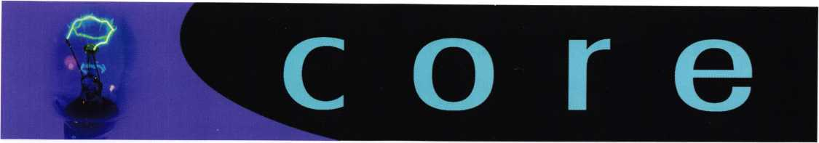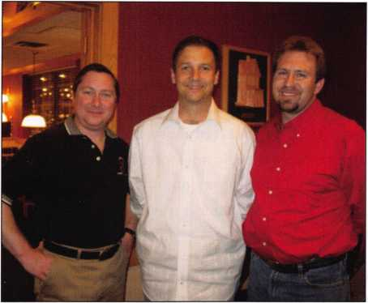

Vernon Kelley, CPL, CIL, Northeast  
Director of of ALOA;

Brian Lamb, CPS-Lockmasters, Inc.;

Terry McClain, CRL-Chairman, Ohio Valley Chapter of ALOA

Thomas G. Klein Scholarship

The Ohio Valley Chapter of ALOA is pleased to announce that the following individu-  
als were winners of the 2006 Ohio Valley Chapter of ALOA's Thomas G. Klein  
Scholarship Raffle held at our regular meeting on April 5, 2006:

* Randall Aylor of Aylor's Lock, Florence, Kentucky;
* Cindy Billheimer of Dan's Locksmithing, Mansfield, Ohio;
* James Dennison, CML of Ace Lock & Key, Camden, West Virginia;
* Al Ostheimer, CML of Al's Locksmith Shop, Sandusky, Ohio;
* Don Rupert, CRL of Rup's Lock and Key, Medina, Ohio;
* Lonnie "Rocky" Sims of Rocky Top Locksmiths, South Hill, Virginia;
* Mehdi Zahedi, CRL of Accu-Key Lock & Safe, Kettering, Ohio.

The winners each received seven day packages to the 2006 ALOA "50th  
Anniversary" Conference & Security Exposition to be held in Las Vegas,NV July 8-16,  
2006

Clark Security Products Educational Week and  
Trade Show

North Central Director Guy Spinello, RL  
(left), and Board Secretary John  
Soderland, CML, CMST (right) were on  
hand in late March at the Clark Security  
Products Educational Week and Trade  
Show in Northbrook Illinois to promote  
ALOA to the attendees and answer any  
questions members had about the associ-  
ation, membership, upcoming events and  
recertification. The Board encourages the  
regional Directors and Officers to make  
every effort to avail themselves to the

membership at every opportunity, and are working hard to provide both a proactive  
and transparent style of government for the association. .

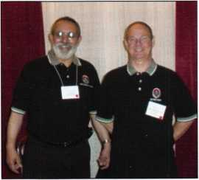

Photos from Lou/Miss and Fox Valley Chapter

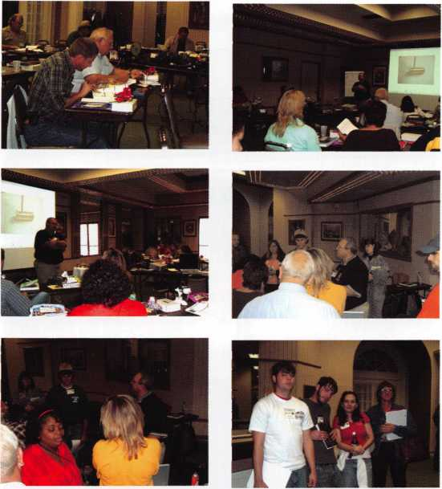

Why Keys are Expensive

When folks call and ask for a price quote to replace a set of keys that got lost for one of the newer cars, the keys that have fancy electronic packages hidden under the plastic head, I know that many of them suffer from a "sticker shock" that's not much different than when they bought the car in the first place. I tell them my price is based on the time it takes to make the mechanical key, the time it takes to program the key, my cost for the key blank with mark up and last on the list is the cost of the computer that does all that fancy programming.

I have a collection of programming computers that I carry around in my service truck, one is nearly obsolete and will only program certain cars that I hardly ever see any­more. These units cost anywhere from a thousand dollars, that obsolete unit, on up to about five thousand dollars for a mult-vehicle computer. That price gets the basic unit- adding the programs for each upgrade costs quite a bit too.

I just upgraded my multi-vehicle computer with software that will permit me to continue my efforts on 2006 model cars along with some programs recently made available for some older cars and trucks. My annual update would have cost $1700.00; but since I purchased multiple upgrades I was able to shave off $450.00. I also had to purchase an upgrade connection cable so I could work on the newer Mitsubishi vehi­cles, another $150 out the door.

If somebody wants to complain about how much something costs, having watched me breeze through making a key, I like to start with an apology, "Sorry it took so long.", or "That only took me 30 years and 5 minutes to make it look that easy." I then show them the neat little computer that hooks up to their vehicle and thank them for helping to pay for all those nice little upgrade packages, (written by T.F. Stern)



Keynotes • May 2006

Mosler Jewelers

by Greg Perry, CML, CPS

What did he break inside?

A customer recently walked in the door of my shop and told a little tale of woe. It seemed his old safe was acting up

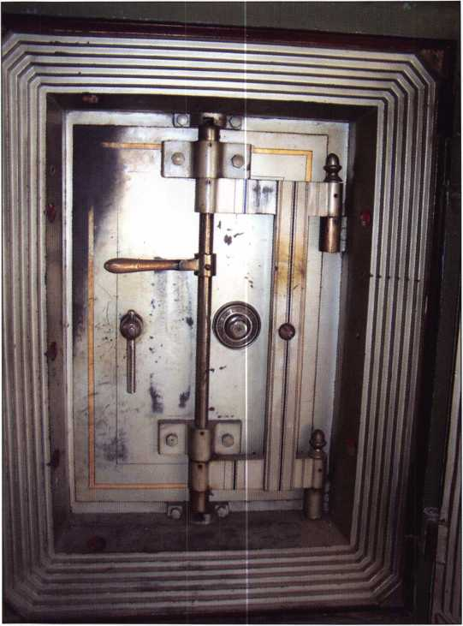

Photo 1

and the dial was getting harder to turn. Trying to solve the problem himself, he thought, “If it gets harder to turn, I’ll just use some locking pliers on the dial which will make it easier.” But after doing so, the lock would not open.

I went out to look at the safe. It was a Mosler heavy, or thick-wall, cast-iron safe with a jewelers safe inside. The

Dilemma

outer door was covered the previous month during a retrofit. The inner jewelers chest can be seen in photos 1 and 2. The dial was hard to turn and using the combination did not open it. The customer had set his own combination when he bought the house that included the safe. The safe had not been serviced in 12 years or more. He was frustrated and didn’t care about the safe anymore. He felt it was too small for long guns and the inner door made it inconvenient to use. He had said that, after it was open, I could have the safe and locks.

I tried the combination, both high and low, by ten numbers without success. I could not feel any wheel pickup but the dial was hard to turn so I couldn’t feel anything. I suspected there was a broken drive pin or spline key. Interestingly, the outer door lock dial did not have patent dates on it; the inner door did, although they were partially obscured by the screw in the middle of the dial. The date Aug 24, 1884 was very readable on the dial. The other dates were March or May and June or July 1884. At least a couple of the dates for the outer door lock matched the dates of some safes I found through my database in Dave McOmie’s The National Locksmith Guide to Safe Opening Volume III. I wondered, “Did somebody swap the dials? Are the locks the same or are there two different locks with the same patent date?” I took some pictures and posted them on the ClearStar Security Network (CSN) web site. Dave LaBarge, one of the world’s studied antique safe experts, responded quickly with his thoughts. I had guessed it might be a Yale 029 1/2 lock but Dave correctly identified it as an 025 1/2. The outer door lock was a Mosler 5H. The drill point to view the action of the fence in the three locks is totally different on each. Dave suggested a drill point at the edge of the gears for the 029 1/2. He added the caveat, “be very careful as you drill. If you drill too deep it will damage the gears.” This location would allow me to probe the wheels around to drop in and open the lock.

10

Keynotes • May 2006

i

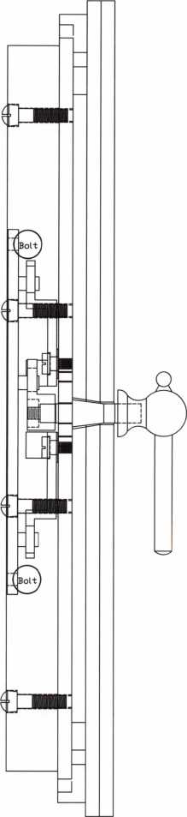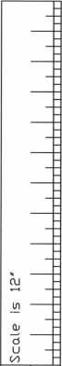

in

L.

Qj

CL

CL

sz

-p

>

(U

CD

75

Ld

\D

o

o

OJ

<3

75

N

c5

ID

E

O

L

1=1

©

I started by removing the pressure bar/hinge assembly. This gave room for straight shot into the lock case. Call me a “chicken” or “cautious”, but I decided to drill a scope hole first. Using an Ed Willis drawing, I picked a location above the bolt and away from anything vital. I wanted the bot­tom of the hole to be located just at the edge of the bolt. This would allow me to view the operation of the wheel pack and flipper fence. Once inside, I could see the wheel pack clearly and all the numbers were off by 10. The other thing I could see was the edge of the fence resting against

the back curb of the  
wheel pack. I tried  
bending a wire to  
push against the  
fence with no luck.

The thing would not  
budge. It was time  
for plan B. I drilled  
at the location sug-  
gested by Dave.

Knowing the depth  
to the lock helped to  
keep me from dam-  
aging the gears.

Once I arrived at the  
lock case, I used a  
flat sharpened drill  
bit from Northwest  
Safe and Vault to  
enter the lock. I  
checked the combi-  
nation wheel pack  
lineup and tried  
again to get the fence  
to drop. Once again,

I tried to pull the  
fence back but it  
would not budge. I  
spent some time try-  
ing other techniques  
before backing off to

rethink my options and repost on CSN.

I really wanted to save the lock. My next thought was to drill for the screws of the pivot arms. Dave and I both scaled a picture of a jewelers safe from Volume III of Dave McOmie’s The National Locksmith Guide to Safe Opening to find the location of the screws. Back at the job site, I drilled and arrived at a location away from the screws but on the cast-iron pivot arms. I decided to punch them off. Before doing anything else, I needed to replace the pressure bar system. The door was heavy and, without the hinge to support it, turning the handle would have been stupid. I turned the handle and it opened. Photo 3 shows the inside

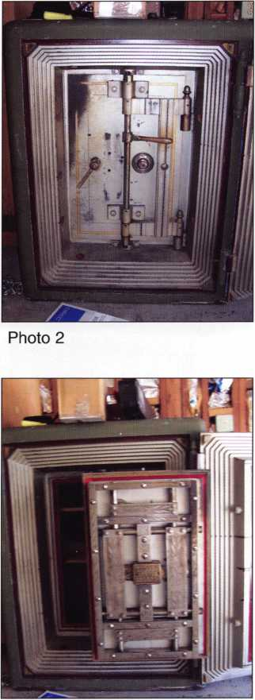

Photo 3

Keynotes • May 2006

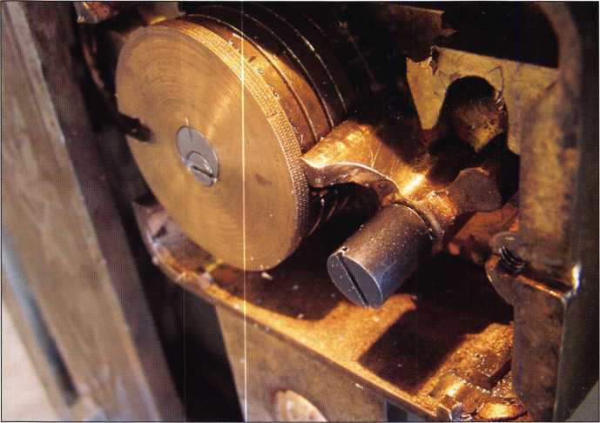

Photo 4

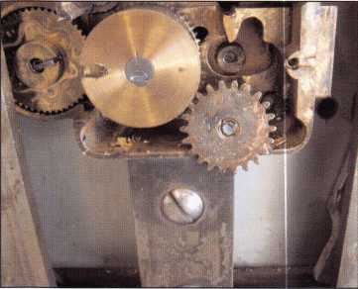

Photo 5

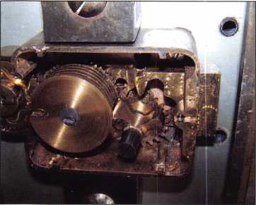

Photo 6

of the door  
right after open-  
ing it. It was  
then time for  
the post  
mortem. What  
was the prob-  
lem? Photos 4  
and 5 show that  
the pivot screw  
for the fence  
assembly was  
broken. This  
was also also the  
reason why the  
fence was rest-  
ing against the  
wheel pack  
curb. It had  
shifted slightly  
to prevent the  
fence from  
dropping.

It was then time to remove the lock. The  
dial had a center screw to remove it from  
the spindle. Once the spline key was  
removed, the drive gear could be  
removed. This allowed for removal of the  
lock case after removing the four lock  
mounting screws. The most interesting  
part to remove was the spindle. Until I  
was in the middle of disassembly, I hadn’t  
thought much about it. It was sand-  
wiched between layers of the door. I dis-  
assembled as much of the door as practi-  
cal, while it was still attached to the  
crane hinge to lighten it. All of the bolt  
work and frame came off the door,  
removing about seventy pounds. I then  
put some wood on the concrete floor  
under the door to prevent damage as the  
door fell. Removing the top two bolts

and one from the bottom of the hinge allowed the door to  
swing down onto the wood before the final bolt was  
removed. I set it on a cart to take back to the shop where  
the door could be delaminated.

Welding was not used commercially until the 1920 s.  
Uuntil then, safes were either cast, screwed or bolted  
together. Delaminating the door required an impact  
wrench with a modified flat screwdriver bit like the one  
seen in seen in photo 11. This door was constructed of  
four 1/2” layers. The first two are about 29” x 19” and  
made up the outer skin, or face, of the door. Next, came  
the 22 7/16” x 12 1/4” hardplate with a 3” wide frame sur-  
rounding the hardplate with mitered corners. Last was the  
inner mounting plate. The spindle could be removed once  
the inner plate was removed. Can anyone guess why the  
numbers were off by 10? The answer can be seen in photo  
12. The spindle actually twisted when the customer used  
locking pliers on the safe. All of the screws holding the  
plates together were 3/4” diameter flat-head screws.

One of the people assisting me on CSN was Tom Gazda.  
Tom offered some suggestions and, once I posted the pic-

S

2

Keynotes • May 2006

When you install Schlage*locks, you know you've done the job tight. After all, our products are among ,h. most durable and dependable on the mark,, today. They're also easy to install, repair and maintain, so they generate fewer callbacks. Which means you're free to concentrate on other things. Like learning how to pick up the 7-10 split.

Real Security Sets You Free

[www.schlage.com](http://www.schlage.com)

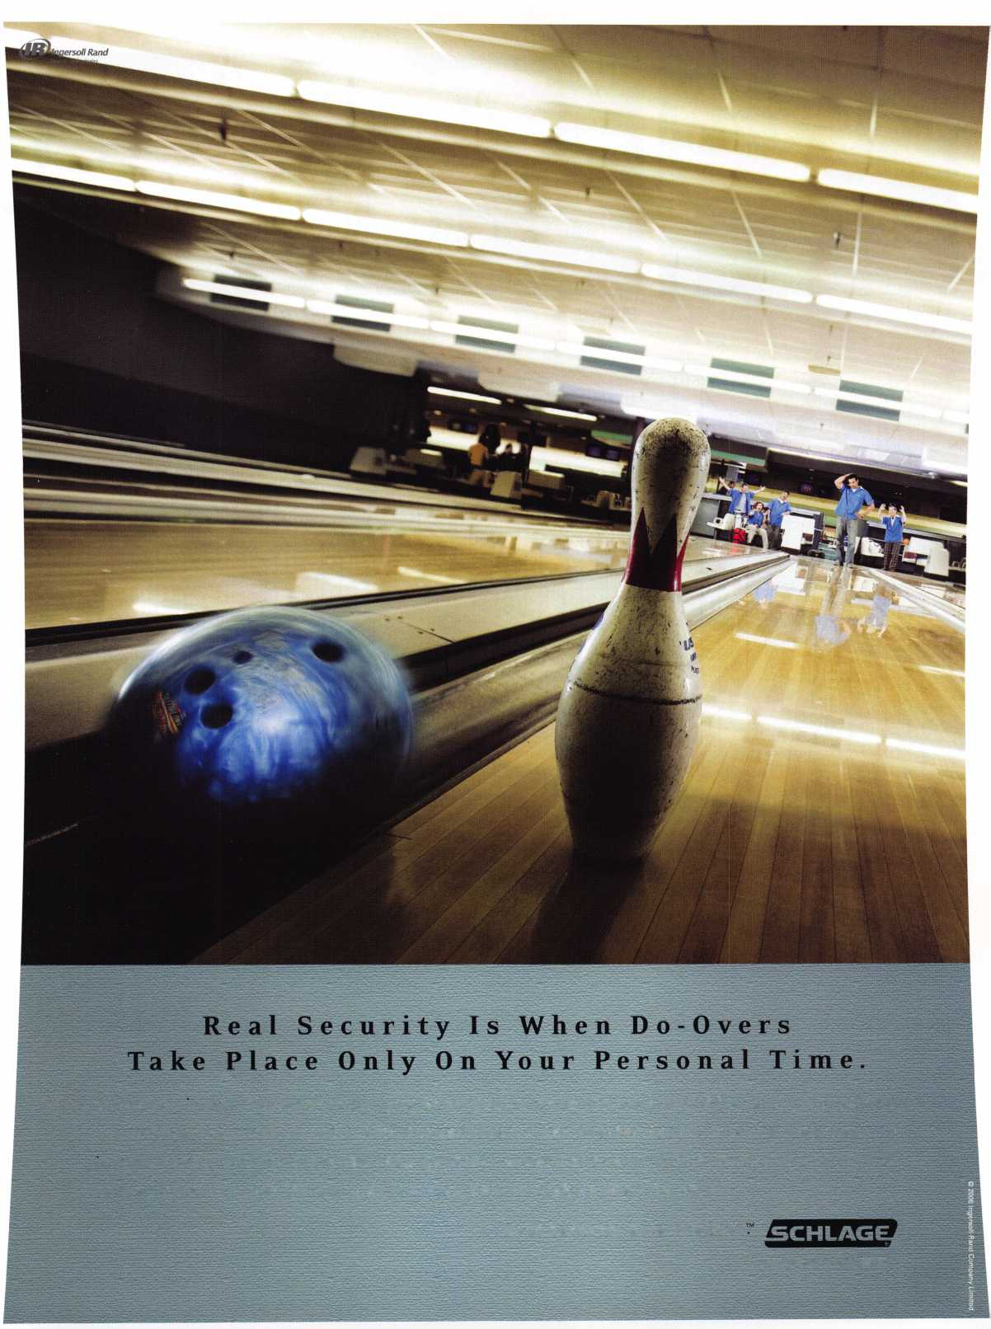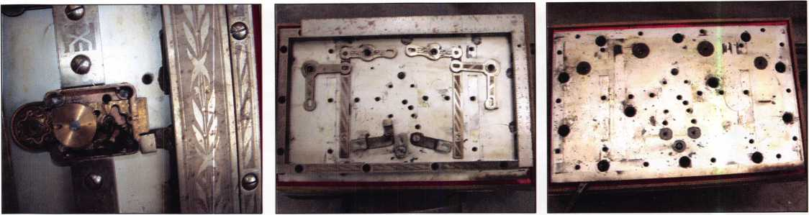

Photo 7 Photo 8 Photo 9

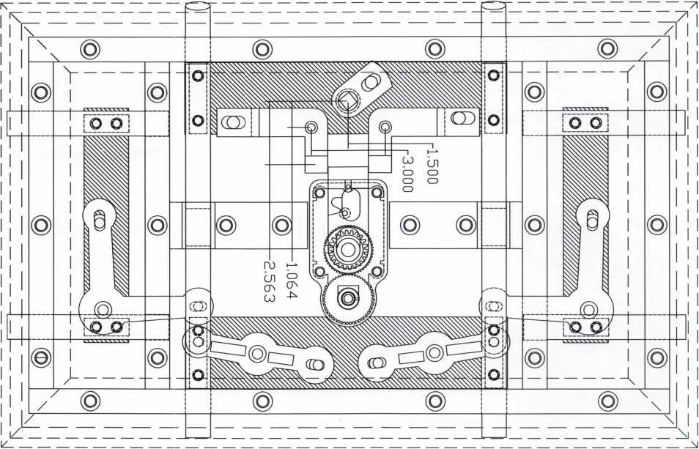

Mosler Jewlers Door with Yale 025 1/2 lock

|  |  |
| --- | --- |
| Xray view of door in the locked position. | Scale is 12' |
| © Ton Gazdo. 2006 - Rev 1 - 4/9/2006 | ih 11111.11Lb ihLiiliiiliii ihliii ihii.ii |

tures, he sent me a CAD drawing of the door. Tom loves to draw and spends time drawing numerous safe locks and safe doors. I sent him some of the parts to get a better idea of the scale. He put together a great set of drawings for this door. A couple of them are included with this article. Tom

combines both a cutaway view and a x-ray view in the same drawing. He can also turn layers on and off within the drawing to focus on particular areas. I suspect we will be seeing more of his drawings in the future.

*

Keynotes • May 2006

**Financing**

**Available**

fmwmte

PowerMate does 100% of the lifting and is ergonomically designed to reduce physical effort used to move heavy loads by 87%.

**♦** Increases job efficiency and productivity 1 **♦** Significantly lowers labor costs.

**♦** Create referrals and repeat business.

**♦** Best in Class post sales support and on-site training.

To learn How PowerMate'’is the ‘SOLUTION” for you, call..

**1**-**800**-**697-6283**

[www.powermate.info](http://www.powermate.info)

PowerMate® is a Registered Trademark of

L P INTERNATIONAL INC.

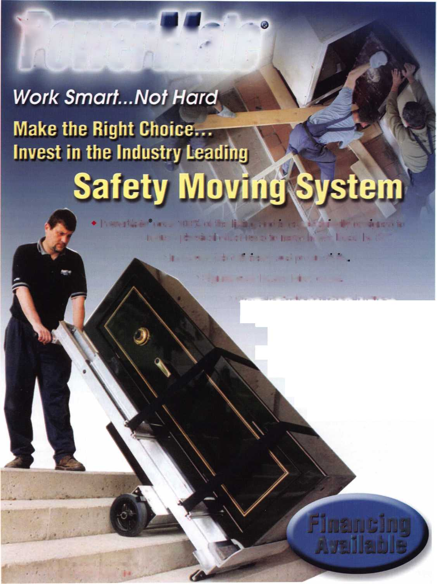

Photo 10

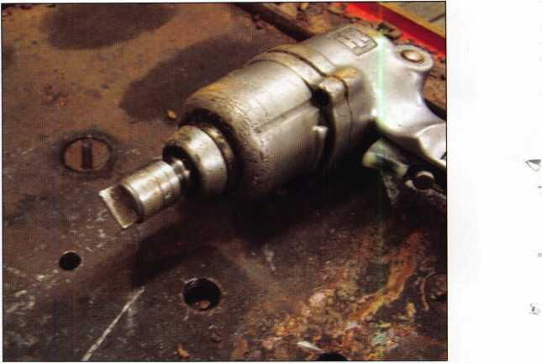

Photo 11

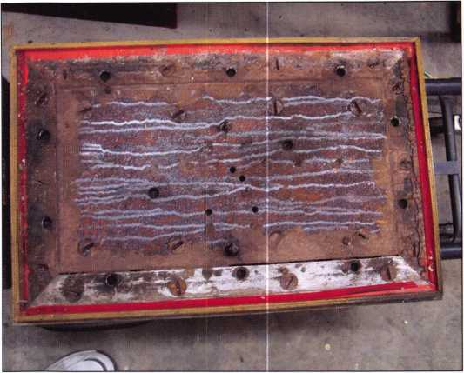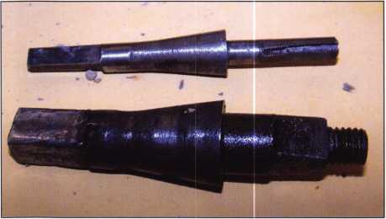

Photo 12

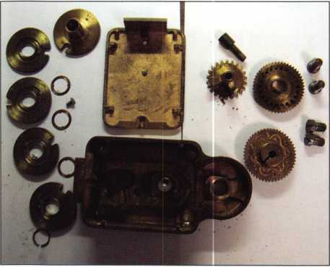

Photo 13

Looking at the methods of manufacturing available in the late 1800s revealed a few interesting details. Mass produc­tion didn’t start until Henry Ford built an assembly line. All the old doors were handmade and the screw holes vary for location by up to 1/2” between them. It is possible that no two doors have the exact same dimensions or parts matching. Tom struggled with the drawings of the pivot arms because I had only sent one of the arms. The scale didn’t add up correctly. He finally called to ask about the size of the missing arm. It was a 1/4” longer than the one I sent him.

This was an interesting opening. It is not often that you get to keep an antique lock and disassemble a door after opening. Malfunctions are interesting. Perhaps I spent more time on this opening than I should have. Though, in retrospect, I’m not certain what I might change if I started over. Maybe I should have punched the pivot arms after the first hole. Of course, I now know the easiest way is to punch the pivot arms but this destroys the arms. If you want to repair, this option might be costly. One thing I love about safe opening is the mental puzzle it takes to overcome a problem. During the battle, it can be frustrating, but as the handle turns it becomes pure joy.

Q.

j



Keynotes • May 2006

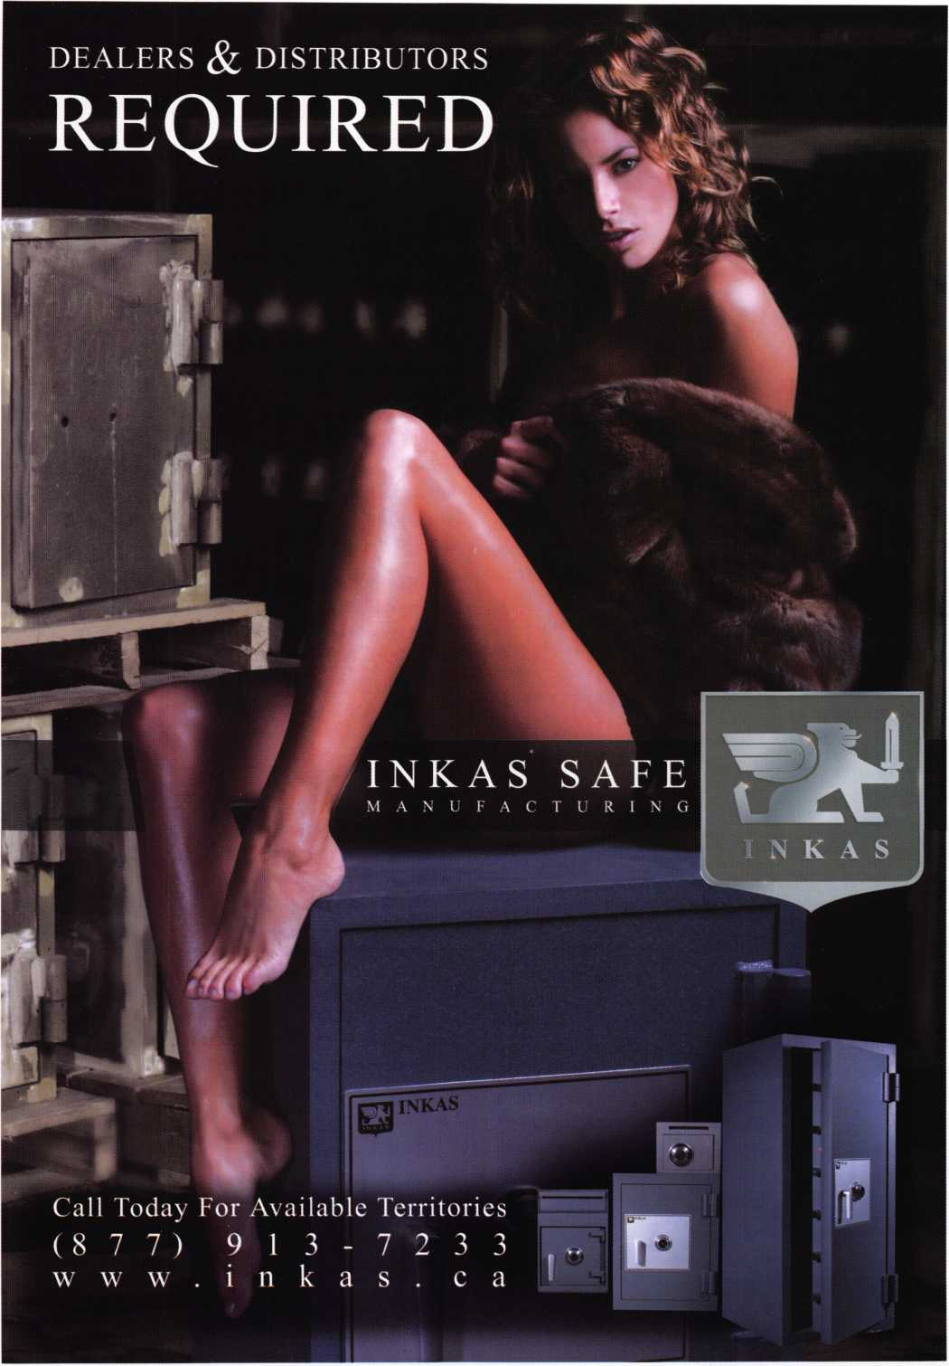

The Lock Speaks

by Dan Cunningham, JD, CRL, CFL, CFATE

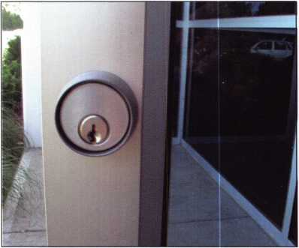

Photo 1

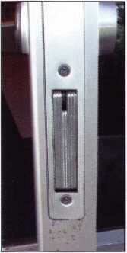

Photo 2

“My shop  
(home) has  
been broken  
into and a lot  
of merchan-  
dise (things)  
have been  
stolen. Can  
you send an  
officer out  
here to inves-  
tigate?” This is  
the usual start

for a chain of  
events that can  
involve the

forensic locksmith in a burglary investi-  
gation that may possibly terminate with  
his appearance in a court of law. At each  
phase of his involvement in the case he is  
getting paid for his time and expertise.

In today’s society insurance fraud is  
becoming a crime of epidemic propor-  
tions. There is not an insurance company  
out there that will not hesitate to imme-  
diately pay off on a legitimate claim.  
Problems arise when the claim is ques-  
tionable.

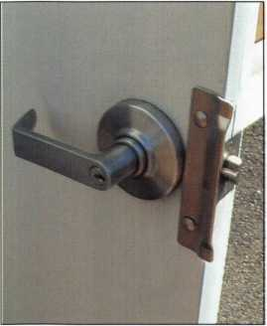

Insurance companies do not  
have the staff or funds to go  
out and investigate each indi-  
vidual claim. All insurance  
companies that cover proper-  
ty claims of a criminal nature  
rely on the police to conduct  
an investigation and to file a  
report of their findings.

Based on the findings of the  
police report and other fac-  
tors used by the adjustors to  
evaluate a claim, the adjus-

Photo 3

tors at the insurance company make the decision to pay or deny the claim. If the police can find no apparent point of entry the claim will almost always automatically be denied.

The problem is with the police officer that goes to the scene and investigates the crime. Most police officers and law enforcement personnel are not trained in methods of lock bypass or an attack on the lock mechanism. They come out and find a window smashed, a door kicked in, or even pry marks on the door next to the lock, there is no problem. The indication of how entry was gained is obvious. It is when methods that are not obvious that the problem arises. Most police officers will report that they found no point of entry into the building and thus it must have been an inside job or the thief had a key.

The bottom line is that most law enforcement personnel, even people from the crime lab, don’t know what to look for or where to look. Two years ago I went to a class taught by Marc Tobias in Vancouver, BC. It was a class on locks, mas­terkeying and bypass methods for locks. The class was for tool mark and firearm examiners from crime labs in the US and Canada. There were about 40 people in attendance, of which five of us were locksmiths. Marc spent most of the class going over the basics of locks and how they work because the majority of the examiners present did not know how a basic lock worked, let alone anything about mas­terkeying or bypass techniques. Even though they worked in a crime lab and at some point in time may be called upon to examine a lock, the majority of they did not even know how a basic pin tumbler lock operated, let along what to look for or where to look for suspicious marks.

In recent years insurance companies are beginning to ques­tion the conclusions of the police reports, especially where the claimant has been a good customer of the insurance company for years and is claiming the business or house was locked and secure and the police investigation found no signs of forced entry and the police list it an “inside job”. Enter the forensic locksmith into the picture.

The forensic locksmith looks at the locks and possible point of entry in an entirely different manner than does the police officer. He knows where to examine the lock for signs of

S

8

Keynotes • May 2006

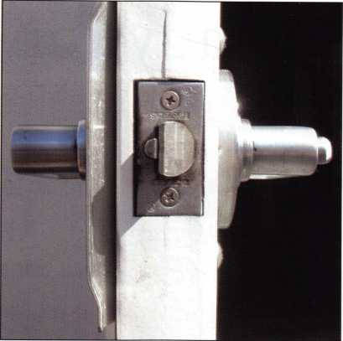

entry that are not readily  
apparent to the untrained eye.

He is familiar with what marks  
left by covert means look like  
vs. the marks from normal day  
to day operation of the lock.

Last year I was called out to  
examine the locks on two  
doors to a commercial build-  
ing. The shop had been bur-

glarized and lost a few thou- Photo 4

sand dollars in equipment. The

police came out and investigat-  
ed the burglary but couldn’t find any sings of any forced  
entry. The investigating officer concluded in his report that  
the owner had left the door unlocked, someone had an  
unauthorized key or it was an inside job.

Because the police officer had not found any signs of  
forced entry the insurance claim was referred to the Special  
Investigations Unit of the insurance company. The SIU  
investigator contacted me and had me examine the locks. I  
examined the glass storefront front door and found it had  
an Adams-Rite swing bolt lock and a Schlage five-pin mor-  
tise cylinder firmly secured in the lock. (See photos # 1 &

# 2) There were no signs of attack on the door or lock.

I examined the lock on the rear door. It was a Schlage  
grade I lever lock mounted on a one hour steel fire door. A  
steel plate covered the locking latch so the latch could not  
be “slipped with a knife blade. The

lock cylinder was a five-pin  
Schlage key-in-knob cylinder, with  
no apparent damage to signs of  
attack on the door or the lock  
cylinder.

(See photos # 3 & # 4)

Suspecting something other than  
obvious entry marks I examined  
the lock cylinder with a magnify-  
ing glass. Under magnification I  
could clearly see a distinct mark at  
the top of the lock like the mark  
left by a “bump key” striking the

lock “talked” to me  
and told me a

bump key was  
used to open  
it.

top of the lock plug. (See photo # 5) I  
disassembled the lock cylinder and  
examined each pin under a magnifying  
glass. I could plainly see the very dis-  
tinct mark of a bump key on the side  
of the face of each pin. (See photo # 6)

Through the use of forensic examina-  
tion I was able to demonstrate that the  
locks on the building had indeed been  
compromised and it was not an “inside  
job” as stated by the police. By means  
of the marks on the cylinder and the

pins, the

Photo 5

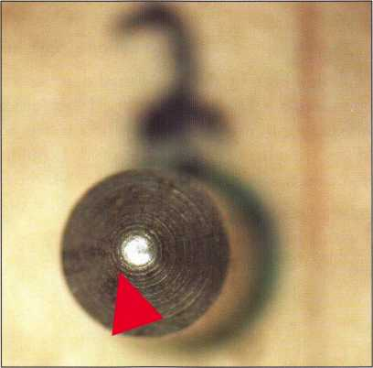

Unfortunately  
information on  
bump keys and

other methods of  
bypass of locks is  
easily found on  
the Internet and

in public libraries. Such information is readily available to  
the general public if they are will-

ing to take the time to look for it.

As locks become more and more  
sophisticated so are the methods of  
compromising these locks and so  
are the crooks that compromise  
them. The need for the forensic  
locksmith is only going to increase  
in the future, as it is only to some-  
one who is trained in the forensic  
examination of locks that the lock  
and the evidence will “talk” to and  
tell what really happened.

Photo 6

Keynotes • May 2006

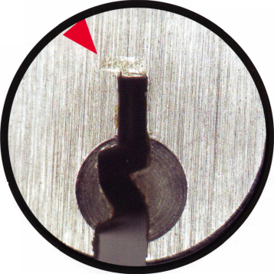

I Got it All Ready for You

by Thomas Stern

I got a call from a young fellow yesterday morning who said  
somebody had taken the keys to his 1995 Chevy S-10 truck.  
The locksmith from the night before didn’t know how to do  
the job since the ignition switch and steering column had  
come out of a junk yard and didn’t match the door key.

With that in mind I told him I could do the job and we  
agreed upon a price knowing that I would have to pick the  
ignition to the start position, remove it and fit the key.

“I’ll call you back after the  
wrecker brings the truck to  
my business; it’s across  
town.” He was afraid that  
the person who’d taken his  
keys would take the truck  
and so he hired a wrecker to  
haul it away as a precaution.

I figured it wouldn’t be  
much trouble to pull the  
spring cover cap, toss the old  
combination and set it up on  
yet a different key since I’d  
have out of the column any-  
way.

The day went by and I had  
plenty to do; he never called  
back, at least not until the  
sun was going down and I  
told him it would have to  
wait until the next day. I

wasn’t about to start on it in the dark.

He called this morning and explained that he’d been by the local GMC dealership parts counter, purchased a new igni­tion switch and they’d already put it together for him with a completely different key so that the old key wouldn’t be able to start the truck. “I got it all ready for you to work on.”

Jim Reed, the fellow who taught me to be a locksmith, had a sign in his shop to explain his prices. I wish I had a copy of it to jog my memory. It went something like this:

Basic Locksmith Work - $ 10  
If you watch - $ 15  
If you talk while I’m working - $ 20  
If you worked on it first- $ 50

I drove the short distance to his location, one of those quick

lube and oil change places. His  
truck was parked in the back  
with the hood up as I pulled in.

I looked inside and sure enough  
the plastic clam shell pieces had  
been removed, along with the  
“Mickey Mouse” ears from the  
ignition switch. The brand new  
ignition switch was sitting in  
the center console.

“I tried to turn the ignition to  
remove it but it just wouldn’t  
turn no matter how hard I  
tried.” I closed my eyes and pic-  
tured the sign in Reed’s Key  
Shop from so many years ago.

“I was trying to save some  
money so you wouldn’t have to  
come out”

“So, how were you trying to  
turn the switch?”, a reasonable

question since I knew he didn’t have a key.

“I used that big screw driver; I hope it didn’t damage any-  
thing.” I took a deep breath and studied the keyway. The  
first three wafers had been crushed and completely  
destroyed. I couldn’t get the proper key blank to even go in  
the lock. “Maybe I shouldn’t have hit it with the hammer?”,  
he added as I was shaking my head.

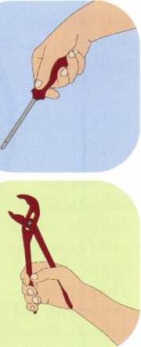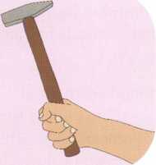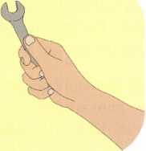

Keynotes • May 2006

I mentioned that the previously agreed price was no longer on the table, that it would cost more since I would have to take the ignition switch out a piece at a time. He was not prepared to pay and so I packed up and got in my truck to leave.

“What am I supposed to do now; you just going to leave me stranded?”, as if it were my fault.

“Call some other locksmith, one who has lots of time to waste; I’m out of here.”

When I was still an apprentice locksmith I would go out on calls as an observer. I remember standing off to the side of a fairly new Mercedes. The owner had locked the keys in the trunk by accident and called to have one of Reed’s locksmiths come out. It couldn’t have been 15 minutes from the time the call came in to the time we arrived. The owner had decided that a pair of scissors might be the per­fect lock pick tool as he pounded the tip into the trunk lock, missing a couple of times as the scissors dug into the once pristine paint surface surrounding the trunk lock.

You have to wonder what kind of chemical imbalance is triggered in the brain of somebody who’d do that. Maybe that’s one of the differences between men and women. Most women, not all, would have patiently waited for the locksmith to perform his special magic, paid for the service and gone down the road. A few macho men are unable to

/ \

You need it When?

**How about now!? :-)**



Another Special  
Value-added Benefit to your

ALOA Membership!

CTirk here



[www.clearstar.com](http://www.clearstar.com) / ALOA

J

accept the fact that a stupid lock has prevented them from moving forward as they pick up their club, bow and arrow, shot gun or what ever “precision tool” is handy or within reach as they detonate the C-4 plastic explosives to get into their car. Maybe that sounds like an exaggeration; possibly the part about the C-4, the rest I’m sure have all been used.

I went on a simple lock out many years ago; it was a brand new Cadillac. The woman who owned the car had com­plete AAA coverage and so it wasn’t going to cost her a penny for my services. When I got there I noticed that something was wrong; all the rubber gasket material around the windows had been chewed up.

“My neighbor has been trying to get in. He’s such a dear; but all he had was a bow saw blade because he lost his Slim Jim.” I had one of my apprentice locksmiths with me that day and he was having trouble containing his laughter. I looked inside the car, observed the cuts on the door key and clipped out a perfect copy. Unfortunately, the “Good Samaritan” had unhooked all the linkage rods on the driver side door and it no longer functioned. Thank goodness the linkage was still working on the passenger side. To top it off, the woman called AAA and wanted to complain that I had destroyed her new car; forgetting all about her neigh­bor and the bow saw blade.

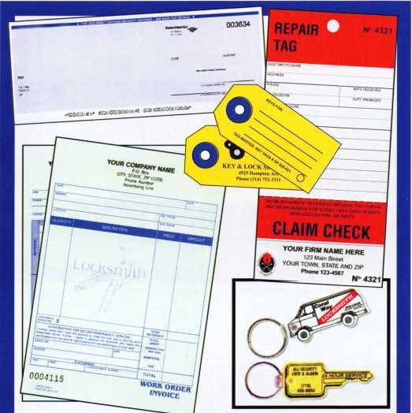

**Professional Business Products**

Invoices Tags *Call for a free*

Checks Key Fobs *brochure and samples*

**Business Magnets** 1**-**800**-**355-6322

Cards Labels [www.pbp2000.com](http://www.pbp2000.com)

Keynotes • May 2006

A Journey Home

by Jim Hancock

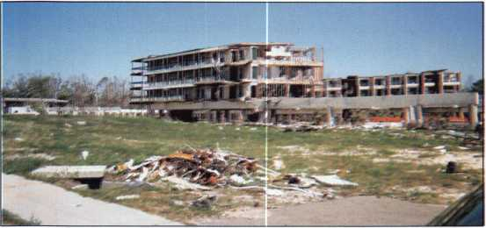

Beachfront Condos

PREAMBLE

Gulfport Mississippi. This is home, although I have lived in  
Texas for over 20 years. It is where I grew up. It is where I  
went to school, learned to drive and perhaps more impor-  
tantly, it is where I began learning this business we all love  
so much. It is where most of my family lives and the place  
where most of my oldest friends reside. It is and always will  
be home.

Gulfport Mississippi. When I left to move to Texas, it was a  
small community of 32,000 people whose only claim to  
fame was that the Port of Gulfport was the major point of  
entry for Chiquita Bananas in the United States. And oh  
yes, the other claim was that the community had survived

Hurricane Camille in 1969. Though battered and severely  
damaged, Gulfport and the entire Mississippi Gulf Coast  
had rebuilt.

Gulfport Mississippi. A community that had long been the quiet studious sibling to the older and rowdier sister city, Biloxi. When casino gaming was allowed in the State of Mississippi, it was Biloxi that boasted the most casinos, over a dozen, while Gulfport had one. It was Biloxi that rivaled the nearby city of New Orleans as a “stay up all night and play” kind of town while Gulfport became the area all of the locals went to live. This allowed Gulfport to grow to over 100,000 people and became the second largest city in the State behind only the capital, Jackson.

Gulfport Mississippi. The greatest little city in southern Mississippi that no one had ever heard of until August 2005. Suddenly, everyone knew where it was. CNN, MSNBC, Fox, Anderson Cooper, Wolf Blitzer all reported from Gulfport; or what was left of it. Hurricane Katrina had taken dead aim at the region and destroyed more lives and property than Camille had some 37 years earlier. Though New Orleans saw the brunt of coverage, it was the Mississippi Gulf Coast that took the more direct hit.

Gulfport Mississippi. Can you ever go home again when home isn’t there?

Beachfront Homes

_

Keynotes • May 2006

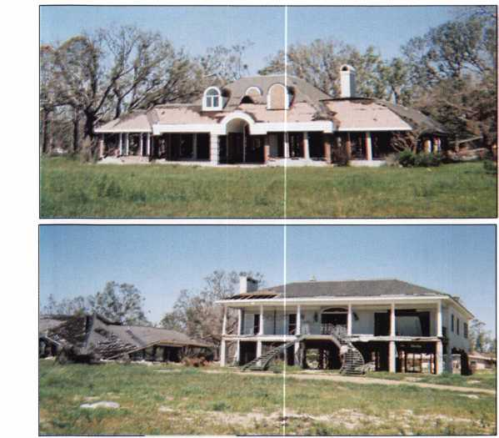

ALOA Elections

**FOR THE OFFICE OF SECRETARY**

VOTE FOR ONE (1) ONLY

(Eligible to vote: Active, Apprentice, Retired, and Life members):

John W. Soderland, CML, CM ST, CIL

I have held the office of Secretary of the Board for the last two-  
year term and have served two terms as North Central Director  
before that.

If elected to continue as Board Secretary for another two-year  
term, I promise to continue to devote my efforts to faithfully per-  
form the assigned tasks and duties of this office and to serve  
the Membership, Board and President of the Association to the  
best of my ability.

**FOR THE OFFICE OF INTERNATIONAL DIRECTOR**

VOTE FOR ONE (1) ONLY

(Eligible to vote: Active, Apprentice, Retired, and Life members whose business  
address is in any location other than the United States or Canada):

Hans Mejlshede, CML

For four years I have been your elected European Director.

These have been some very interesting years. For that reason, I  
am seeking the new office as International Director. With an  
increasing amount of locksmiths around the world learning eng-  
lish, ALOA has an opportunity to find new members outside  
USA

I have a Masters Degree in mechanical engineering from the  
University of Denmark. I am a CML and I have been a lock-  
smith all my life. I am the owner and manager of a locksmith  
company in Copenhagen, Denmark with more than 50 employ-  
ees. I am the past President of European Locksmith Federation  
and in the Danish association I have held every board position.

I would like to have the opportunity to sign up a lot of new  
members from around the world.

This year, it's even easier  
to make a difference at  
ALOA with Online Voting!

If you are  
voting online, you  
**MUST REGISTER  
now**at

[www.aloa.org/vote](http://www.aloa.org/vote)

2006

**FOR THE OFFICE OF ASSOCIATE DIRECTOR**

VOTE FOR ONE (1) ONLY

(Eligible to vote: Associate Members):

Dan Floeck, Jr.

My wife and I have been married for 32 years and we have  
three children. I am a member of the Presbyterian Church. I pur-  
chased H L Flake Company in 1988 and took the company  
nationwide in 2001. I am an active member of the Security  
Flardware Distributor Association. I enjoy bird hunting. I also  
enjoy golf and while I talk a good game, I generally shoot in  
the nineties.

**FOR THE OFFICE OF**

**SOUTHWEST REGION DIRECTOR (One-year term)**

VOTE FOR ONE (1) ONLY

(Eligible to vote: Active, Apprentice, Retired, and Life members whose business  
address is in AZ, CA, CO, HI, NM, NV, or UT):

Greg Parks, CRL

I have been active in the locksmith industry since 1982 and  
have been a member of ALOA since 1989. I earned a B.S.  
Management degree from Northern Illinois University. As  
founder of Accurate Security Pros in San Diego, I originally  
worked from a kiosk performing key cutting, rekey and auto lock  
services. My company has grown into a diverse team of security  
professionals offering mechanical and safe services, while  
actively embracing access control and CCTV system integration.

**FOR THE OFFICE OF  
NORTHWEST REGION DIRECTOR**

VOTE FOR ONE (1) ONLY

(Eligible to vote: Active, Apprentice, Retired, and Life members whose business  
address is in AK, ID, OR, MT, WY, APOSF, WA, Alberta, British Columbia, Northwest  
Territories, Saskatchewan, Yukon Territory):

James Jeffries, CPL

The past two years, while serving as your elected representative,  
have been a wonderful experience. I am once again running  
for the Northwest Director position of ALOA. I represent my  
fellow ALOA members and I have helped start some ground-  
breaking programs that have come to fruition during my term.

There are more programs that I would like to see come to pass.

Together, we can make some wonderful changes for the good  
of the industry.

I hope to see the "Shop Certification" program finally become a  
reality by working hand in hand with the alarm and auto indus-  
tries and NASTF. I wish to see all locksmiths receive the recogni-  
tion they deserve.

I am also a strong supporter of education. ALOA Education  
includes Continuing Education and I would like to see more  
ALOA members involved with the PRP program. The Continuing  
Education points system is fair and I am proud to have partici-  
pated in its creation. I believe we need to recruit each and  
every locksmith to join ALOA and raise professionalism and  
proficiency in the industry. Together we can do this. Voting for  
me as your Northwest Director is a great start.

I want to see ALOA complete more of the programs that have  
been in the works. I want to see more involvement in all upcom-  
ing legislation so that the locksmith receives his fair share of  
amendments passed by state assemblies. I would love to see a  
national standard for locksmiths and a licensing law that has  
"teeth" so we can get the fly-by-nights out of our industry.

Cast your vote for Jim Jeffries and call me toll free at  
877-241-6978 to let me know of your concerns and ideas. I will  
present them directly to the Board and together, we can make  
things happen for the betterment of all.

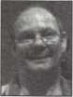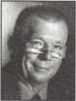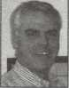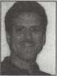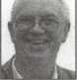

FOR THE OFFICE OF

NORTHWEST REGION DIRECTOR, contd.

Keith Whiting, CML, CFL

Keith has been in the security industry for 27 years, 25 of those were were spent as owner of a full-service locksmith business with two retail stores and three service trucks. Since moving to the Pacific Northwest in 2003, he has been an active member in the Pacific Locksmith Association and is on the Education Committee for the Pacific Security Conference, he has been employed as a commercial sales representative within the security industry in Portland, Oregon for two years.

A member of ALOA since 1982, he achieved his CML certifica­tion in 1992 and is also a Certified Forensic Locksmith in the International Association of Investigative Locksmiths. As a mem­ber of the California Locksmiths Association, he served in vari­ous chapter offices and as Vice President at the state level. He has taught for Mas-Hamilton, CLA, PLA, IAIL, and ALOA. He is an expert witness and does forensic investigations on a part-time basis.

Keith believes strongly in continuing education and, as a Director and Instructor, will bring frequent high-quality ACE and local association-independent education and PRP opportunities to the Northwest.

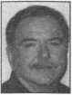

Keith states, "Membership in the Northwest must be increased so that we have a stronger voice in the issues facing us in the coming years. The Northwest ALOA membership deserves a strong ALOA voice and Keith will bring that voice to the ALOA Board. Future licensing and legislation issues need to be defined and written to benefit the locksmith industry and then addressed by the ALOA Board in a manner supportive of the Northwest ALOA members." He also believes we must be cognizant of leg­islation brought forth by others that is not beneficial to our indus­try and work through ALOA to thwart those efforts before they become law and detrimental to us all.

Jamie Vos

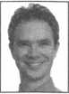

Jamie Vos has been in the locksmith trade since birth. He is a second-generation locksmith that began "working" in his dad's shop when he was old enough to hold a pick. He worked part time during high school and after his high school graduation, he went straight into the trade and began his full time career in the world of security. Soon, he took on management of the locksmith division of a security company and, in 2004 assumed the role of General Manager of Security Solutions/Bellingham Lock & Safe, Inc. Running the company, which is comprised of five divi­sions, takes most of his concentration, but he finds it exciting and challenging.

1. Jamie would make ALOA a resource for all of its mem­bers: a) One man locksmith businesses; b) Small locksmith business owners; c) Large locksmith business owners; d)

All employees of locksmith businesses; e) Mobile locksmith businesses;

1. He would see that Locksmiths are recognized as a certified trade so that the employees are properly compensated for their knowledge and efforts.
2. He would see to the preservation and longevity of the lock- smithing trade.

FOR THE OFFICE OF

SOUTH CENTRAL REGION DIRECTOR

VOTE FOR ONE (1) ONLY

(Eligible to vote: Active, Apprentice, Retired, Life and Associate members whose busi­ness address is in AK, KS, LA, MS, OK, and TX):

C.D. LIPSCOMB, CML, CPS

C.D. has worked in the physical security industry since 1974.

He started out as an institutional locksmith for Navarro College in Corsicana, Texas. In addition to physical security work, he has a working background as a construction engineer, carpen­ter, and contractor. Currently, Mr. Lipscomb operates a full serv­ice, retail storefront locksmith shop with multiple outside service vehicles in Corsicana, Texas. He is a member (and Board Member) of ALOA, SAVTA, and five other local locksmith asso­ciations. In addition to managing a physical security business,

Mr. Lipscomb is an ALOA certified instructor and currently teaches various locksmithing classes for locksmith associations.

For the last 4 years, Mr. Lipscomb has served the members of the South Central region of ALOA as Regional Director to the ALOA Board. Mr. Lipscomb believes in ALOA as a member-ori­ented organization. During his two terms in office, C.D. has attended locksmith association meetings at all local and state locksmith associations in the South Central Regions gathering input from members to relay to the ALOA Board. During his terms in office, Mr. Lipscomb has logged many thousands of miles traveled yearly in the course of representing ALOA mem­bers. he considers representing the South Central Region to be one of the great honors of his life.

C.D. Lipscomb is currently running for a third and final term as an ALOA Board member and South Central Region Director and asks the members of the South Central Region to see fit to vote for him.

Richard M. Sanchez

I am a native Texan from the small town of Ganado. I set about on my life's journey when I was introduced to the automotive industry. At an early age, I assisted my father as a mechanic in his auto repair shop. My father, a tough mentor, instilled the val­ues of a strong work ethic, integrity, and loyalty in me. I never settle for second best as a result of this upbringing.

Throughout my life and career I have continued developing this strong work ethic by completing school, competing as a distance runner and working as a safe deposit technician. I cemented my destiny shortly after graduating from high school when I opened my own locksmith company. Locksmithing is a trade I have remained loyal to for over two decades.

For over twenty years, I have been an active member of The Associated Locksmiths of America. I am also a member of the Safe and Vault Technicians Association. I served one year as Parliamentarian on the TLA Board and feel that I have benefitted greatly from my association with these organizations. I wish to remain loyal by giving something back to the profession that gave so much to me. I am pleased with the ideas and vision that ALOA offers for the future. I would like to be a part of that

H

process and continue to improve and help our industry. I serve  
as a mentor to young prospects who want to enter the trade. I  
teach ethical responsibility and professional skills to enhance the  
industry's image. I am equally dedicated to my loving wife and  
two daughters, the oldest of whom wishes to follow in my foot-  
steps.



**FOR THE OFFICE OF  
NORTHEAST REGION DIRECTOR**

VOTE FOR TWO (2) ONLY

(Eligible to vote: Active, Apprentice, Retired, Life and Associate members whose busi-  
ness address is in CT, DE, DC, KY, ME, MD, MA, NH, NJ, NY, OH, PA, Rl, VT, VA,  
WV, APONY, Quebec, Labrador, Newfoundland, Nova Scotia, New Brunswick,  
Prince Edward Island):

Robert (Bobby) DeWeese, CML

I became a locksmith in 1980, have been a member of ALOA since 1990 and a member of SAVTA since 1999. Additionally, I have been a member of the Maryland Locksmith Association since 1987 where I have served as Secretary, Vice President and four terms as President. I have also served in the positions of Editor, Membership Chairman and Education Chairman.

Tom Foxwell, Sr.

A native of Baltimore, Tom served in he United States Marines and was attached to the White House Emergency Evacuation — HMX-1 with a White House top-secret clearance. He left the Marines in 1967 and started working in the a locksmithing business. He has been working in the industry ever since. He currently works with Technical Sales, Inc.

ALOA ACE Instructor since 2000

ASSA Regional Certification/Training Instructor since 1998

KABA UNICAN factory-trained Certification Instructor since 1992

SECURITRON factory-trained Certification Installer Instructor since 2002

HES factory-trained Product Instructor since 1990

Membership in Door and Hardware Institute national, Vice President of Baltimore Door and Hardware Association, Past Vice President and current Advisory Board and Benevolence Committee Member of Maryland Locksmith Association, Greater Philadelphia Locksmiths Association, Virginia Locksmith

H

Association, Institutional Locksmith Association, Maryland  
Burglar and Fire Alarm Association, Association of School  
Business Officials

Tom was also the year 2000 recipient of MAILA's  
Keith Lewis Award.

Nicholas Hart, CPL

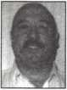

After graduating from college in 1976, I became an Industrial  
Arts Teachers for special-needs kids. During the summer from  
1981 to 1983, I worked for a local locksmith learning the trade.  
I continued teaching until 1984 when I became a full-time lock-  
smith. In 1987, I joined ALOA and over the years, passed the  
PRP earning the CPL designation. I have served as President of  
the North Jersey Master Locksmith association on two different  
occasion, each a two-year term. I am presently the Secretary.  
After working in the trade and working for others, in 2000 I  
bought Pete's Lock and Key in Fort Lee, New Jersey. Having a  
background in education, I feel that no matter how old you may  
be, you can always learn something new. With the security  
industry changing so rapidly, it is a must that we locksmiths stay  
on top of our game. We need to continually take classes to edu-  
cation ourselves. We need to be in the forefront of new technolo-  
gy and be leaders within the security industry. The future is now.

Over the years, I have written for The National Locksmith, Keynotes, and most recently, Safe and Vault Technology. In 1996, I was awarded the Keynotes Author of the Year Award and I am a member of the ALOA's President's Club.

I consider myself extremely blessed to be a part of an industry that I love. Together with my wife, Theresa, I own a mobile lock­smith and safe business in Baltimore which is in its eighteenth year.

I am pro legislation if it is done in the interest and with the full input of the locksmiths it will effect. I've served as a member of the Maryland Committee for Locksmith Legislation where I gained a wealth of insight to how the legislative process works. Let me say, it ain't pretty.

I've also been very involved with education on the local level over the years and truly believe it is the backbone of our indus­try's future. If we don't continually move forward, the world will leave us in it's dust.

Finally, I want to be the "voice of the little guy." Sometimes, it seems to me, like the mobile and small shop operators have a tendency to be overlooked in this industry. Anyone who knows me, knows that I can be a real pain when I see something hap­pening that I believe is wrong. However, they also know that I am very good at working others to achieve positive results and make things happen.

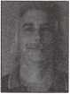

I hope to bring all of this experience to the ALOA Board as a  
way of giving back to an industry that has been so good to me  
and my family for the last 25 years.

I would consider it an honor to serve as Northeast Director and  
would appreciate your vote.

|

This year, it's even easier to make a  
difference at ALOA with Online Voting!

If you are voting online,  
you **MUST REGISTER now**at [www.aloa.org/vote](http://www.aloa.org/vote)

r

The undersigned, being an Associated Locksmiths of America, Inc. (ALOA)

member, hereby appoints Kim Crawford, CPA and Mary May the proxies and true and lawful attorneys of the undersigned to attend the Meeting of the Membership of ALOA to be held at 3500 Easy Street, Dallas, Texas 75247 on June 9, 2006 at 10 a.m. or any adjournment thereof, and to vote on behalf of said ALOA Member as designated below:

FOR THE OFFICE OF SECRETARY

VOTE FOR ONE (1) ONLY

(Eligible to vote: Active, Apprentice, Retired, and Life members):

* JOHN W. SODERLAND, CML, CMST, OIL

FOR THE OFFICE OF INTERNATIONAL DIRECTOR

VOTE FOR ONE (1) ONLY

(Eligible to vote: Active, Apprentice, Retired, and Life members whose business address is in any location other than the United States or Canada):

* HANS MEJLSHEDE, CML

FOR THE OFFICE OF ASSOCIATE DIRECTOR

VOTE FOR ONE (1) ONLY

(Eligible to vote: Associate Members):

* DAN FLOECK, JR.

FOR THE OFFICE OF SOUTHWEST REGION DIRECTOR

VOTE FOR ONE (1) ONLY

(Eligible to vote: Active, Apprentice, Retired, and Life members whose business address is in AZ, CA, CO, HI, NM, NV, or UT):

* GREG PARKS, CRL

FOR THE OFFICE OF NORTHWEST REGION DIRECTOR

VOTE FOR ONE (1) ONLY

(Eligible to vote: Active, Apprentice, Retired, and Life members whose business address is in AK, ID, OR, MT, WY, APOSF, WA, Alberta,

British Columbia, Northwest Territories, Saskatchewan, Yukon Territory):

* JAMES JEFFRIES, CRL
* KEITH WHITING, CML, CFL
* JAMIE VOS

FOR THE OFFICE OF SOUTH CENTRAL REGION DIRECTOR

VOTE FOR ONE (1) ONLY

(Eligible to vote: Active, Apprentice, Retired, Life and Associate mem­bers whose business address is in AK, KS, LA, MS, OK, and TX):

* C.D. LIPSCOMB, CML, CPS
* RICHARD M. SANCHEZ

FOR THE OFFICE OF NORTHEAST REGION DIRECTOR

VOTE FOR ONE (1) ONLY

(Eligible to vote: Active, Apprentice, Retired, Life and Associate mem­bers whose business address is in CT, DE, DC, KY, ME, MD, MA, NH,

NJ, NY, OH, PA, Rl, VT, VA, WV, APONY, Quebec, Labrador, Newfoundland, Nova Scotia, New Brunswick, Prince Edward Island):

* TOM FOXWELL, SR.
* NICHOLAS HART, CRL
* ROBERT (BOBBY) DEWEESE, CML

Print/Type name of ALOA Member Member Number

Member Signature Date

This proxy must be signed and dated with member number to be considered valid. It must be  
received no later than June 8, 2006 and be mailed/faxed only to:

Associated Locksmiths of America • Attn: Mary May  
3500 Easy Street • Dallas, Texas 75247 Fax: 214-827-1810

t

! Dear ALOA Members:

0

j The Bylaws allow voting by proxy, a procedure that ; will allow all members to participate in the election of

I their respected directors and/or officers. A proxy

0

! allows you to authorize someone to vote for you at a j meeting. As President, I have called a special member- i ship meeting at 10 a.m. June 9, 2006, at ALOA 1 Headquarters, 3500 Easy Street; Dallas, TX. The pur- j pose of this meeting is to elect the officers and direc- ; tors for the association. The ballot is in the form of a ! proxy, prepared for you to give specific instruction to

| the holder of the proxy. This will ensure that your vote

; is counted exactly as you desire. You must provide ! your name, member number and date, and you must

| sign the form. Failure to properly complete the proxy

; may result in your ballot being invalid. Although the

1 elections for some races are uncontested, you should

1 still vote. Please vote for Secretary and your representa- | tive Director(s). Write-in candidates are not allowed,

! and there will be no one "running from the floor" at ! this special meeting of the membership. Vacancies for ; Secretary, Associate Director, International Director and ; Directors from the Southwest, Northwest, South Central ! and Northeast Region exist and therefore appear on j this ballot. Please vote online, mail or fax the proxy as

| soon as possible. In order for your vote to count, the

1 holder of your proxy, as designated, must be present | at the meeting and have the properly completed proxy ! with him/her. This means that your ballot must be S received no later than Thursday, June 8, 2006. You do

j not have to designate Kim Crawford, CPA and Mary

j May as your proxies. You may give your proxy to any-

I one else, but they must attend the special membership

j meeting on June 9, 2006 with your signed and dated

; proxy in hand. Please participate in the future of your

! association!

8

1

8

! Sincerely,

! ASSOCIATED LOCKSMITHS OF AMERICA, INC.

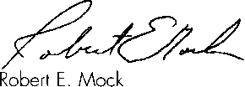

! President

B

8

0

B

B

e

j

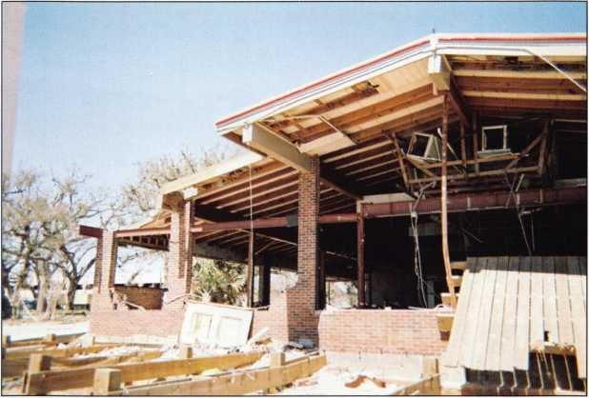

PRE-TRIP JITTERS

I had known about this trip to teach for the  
Louisiana-Mississippi Locksmiths Association  
Spring Convention for months. Having taught  
for the better part of a dozen years and teaching  
subject matter that I can teach in my sleep (and  
probably have a couple of times) the “stage fright”  
nervousness about teaching left me years ago.

However, as I get ready to pack my bags and toys  
to head out to Hammond Louisiana, I was more  
nervous than I had been in quite some time. But  
the nerves were not because of the class I was  
teaching. The jitters were brought on by the  
prospect of what the area, home, were going to  
look like when I arrived. Yes, all of the major

news agencies reported for weeks from the area after  
Katrina but like most anything else; television never

does justice to the situation. Plus, although New Orleans is  
like a second home to me, the lion’s share of the coverage  
involved the “Big Easy” and not the area that was more  
directly affected by Katrinas wrath, the Mississippi Gulf  
Coast and specifically, Gulfport. Since the Tuesday follow-  
ing the storm I had spoken to my family frequently getting  
updates on the progress of their personal rebuilding as well  
as Gulfport’s. And every time we spoke I mentioned com-  
ing to Hammond, a mere 45 minute drive from Gulfport.  
Every time I mentioned it, I got the same response, “Not  
now. You do not want to come home right now. It’s bad”.

Beachfront Restaurant

I remember 1969 vividly. Hurricane Camille struck the area with a fury that had never been seen before and was purportedly the “Storm of the Century”. A never-to-be- repeated phenomena. It so devastated the Gulf Coast that even today there are signs of that long-ago damage. Then, Katrina came through, within just a few miles of the same landfall. The destruction was exponentially worse than Camille. What was I going to see? I wondered. How would it affect me emotionally? The butterflies were churning a mile a minute.

NOT SO BAD... YET

As I drove along Interstate 10 through southern Louisiana, my jitters subsided a great deal because the damage along the way did not seem overwhelming. There were “blue roofs” (tarp covers) on houses as well as trees bent oddly but nothing that looked like the damage I expected this deep into the state. As I merged onto Interstate 12 from Baton Rouge going toward Hammond, I had almost for­gotten the hurricane and was simply cruising along. I was brought back to reality as soon as I arrived in Hammond. There were billboards missing, business signs in shreds, and trees toppled and sheered. It really hit home when I

REALITY

“Oh my God” is all I could say. As I drove south on Highway 49 toward the beach, the devastation was obvi­ous. Roofs were missing from houses and buildings. Window openings were still boarded up by plywood. This was the norm, not the exception even though it had been 7 months since landfall. The lack of trees and leaves struck me immediately. When I think of home, one of the things I see in my mind is the majesty of 40-50 foot tall pine

arrived at the hotel and was told the

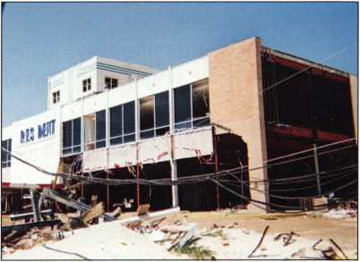

room avail-  
ability was  
minimal  
because of  
the out-of-  
town cleanup  
and rebuild-  
ing workers.

Some evac- Broadwater Hotel

uees were still

displaced in the hotel, as well. The reality of the situation  
hit harder when I went out for dinner at a national chain  
restaurant. I was told that they had already closed for the  
day because they did not have enough employees to run  
the business. People had left the area before or shortly after  
Katrina and had not returned,  
leaving a shortage of manpower.

If this is how things were 60-70 miles from the “epicenter”  
of Hurricane Katrina’s path, I could not imagine what  
things were going to be like as I got closer to home.

Keynotes • May 2006

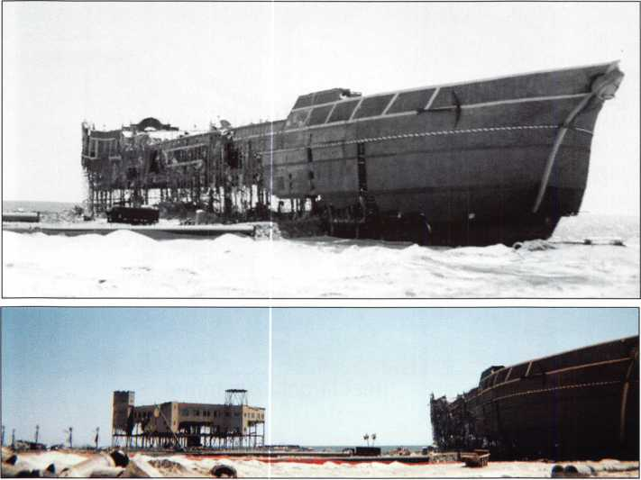

Treasure Bay Casino in foreground;  
original location in background

trees with evergreen needles and oaks that kept their leaves almost year round. What I saw on my visit was pine trees that had been reduced to half their size. They were broken and bent in ways that seem impossible, while the oaks that remained standing were completely barren of leaves. Even more overwhelming were the massive roots of the trees lying on top of the ground as if the water and wind simply pulled them out of the earth as if weeding a flower bed.

My first stop along the highway was at 2416 29th street. This is the address of the two-story house I grew up in. It is the house where my family gathered for birthdays and holidays. It is where all of my neighborhood friends would come on weekends to hang out. It is where my grandfather added a block building onto the front of the house that would become the location for Hancock and Sons Lock and Key, the family business. It was in that block building that the family took shelter to escape the fury of the winds during the eye of Hurricane Camille. The house was gone. Completely gone. It is emotional, to say the least.

After leaving 29th street, I continued south on Highway 49 toward the downtown area. Just off 25th Avenue,was Pete’s Electric. This was the place my grandfather worked when he began his locksmith career. I spent many hours in the lock shop there as a young child and it was where I actually started to learn locksmithing. The shell of the southwest corner of the building was standing. However, the entire east side of the building, where the lockshop and

automotvie work bays once stood, was  
destroyed. There was lumber and glass  
and twisted metal in a grotesque pile  
on top of a slab. It looked as if some-  
one simply dumped a truck full of  
building materials on the ground in a  
pile. This once prominent and long-  
standing community business was on  
life support, operating from a house  
across the street. Another piece of my  
history was destroyed.

I turn eastbound onto Highway 90  
from downtown Gulfport. Highway 90  
is the beachfront drive. It is where as a  
youth I spent many nights with my  
friends, cruising up and down the  
beach. In more recent years, it became  
the home of the newest local attrac-  
tion; the casinos. As twilight  
approached, it was almost eerie how  
quiet and dark it was on the road. In  
the last few years, the lights from the

casinos and clubs and hotels lit up the sky along the beach-  
front. The traffic had started to rival cities twice the size  
with locals and tourists packing four lanes in both direc-  
tions. Now, it was very dark. There were virtually no lights  
along the roadway and there was almost no traffic. The  
casinos were gone, along with the clubs, hotels, apartment  
and condo units, restaurants and stores. Perhaps the thing  
that stands out most is the missing houses. This area once  
contained some of the most beautiful old homes anywhere.  
There were antebellum style, southern pier and beam with  
large columns in the front, wrap around porches and gor-  
geous oak trees shading it all. Now, there are FEMA trailers  
sporadically dotting the landscape underneath the rem-  
nants of the old trees. When a house appeared, it was a  
mere shell of its former grandeur or it was crushed into a  
pile of rubble.

Off Highway 90 on Courthouse Road was where the last vestige of my family’s business stood; Hancock Lock and Key. My brother sold the business some years ago to his brother-in-law and they retained the name. It was in a building one block off of the highway, but about a mile from the waterfront. I say it “was” because the building was totally gone. There is no sign that it ever existed. All of the inventory washed out with the tides. Other buildings in the vicinity that remained standing had 8 to 10 feet of water in them at the height of the storm. Given the dis­tance from the water and the height above the water line,

Keynotes • May 2006

it seems almost impossi­ble.

Although I was going  
through some sensory  
overload, I continued  
east into Biloxi to take  
it all in. Beauvoir, the  
last home of Jefferson  
Davis, which had with-  
stood over 150 years of  
storms was gone. The  
Broadwater Hotel, a  
favorite of Presidents  
such as JFK, entertain-

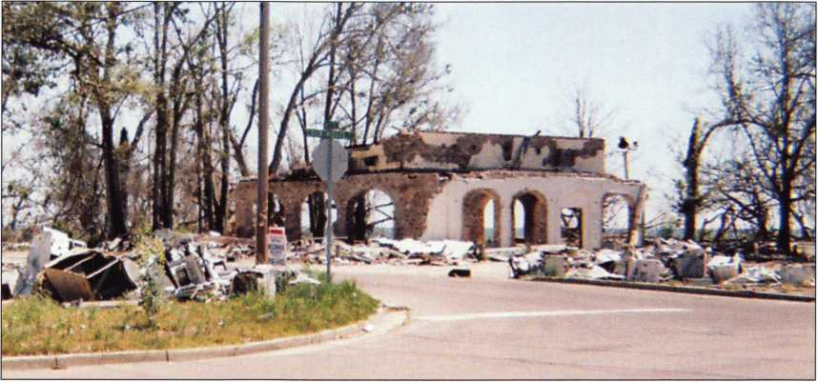

I had seen all I could stand for one day. I was warned by family and students in my current class that it would be bad. After having gone through Camille, I was sure I was braced for what I might see. I was wrong. It was worse than I could possibly have imagined and the blow was lessoned only by the lack of light in the early evening hours. I decided to leave and return during the daylight for a final tour before heading back to Texas.

HOPE

In the light of day, the destruction looked even worse. There were more piles of debris than you could imagine. Whole neighborhoods were flattened. Businesses that once thrived were gone with no sign of return. Nowhere can you look without seeing the devastation left in Katrinas wake. The entire downtown Gulfport area looked like the scene out of a disaster movie. Gutted buildings, brick piles, tattered signs and billboards flapped in the gentle wind that blew off the gulf. There were limbs from whole trees sticking up from the gulf, leaving the eerie impression of a flooded civilization just beyond the sand beach. The once white man-made sand beach itself is a dingy grey with spots along the 26 mile stretch still littered with the bounty of the storm surges retreat. Bridges that once spanned the Bay of Saint Louis

Even in all this destruction, there was hope. As I drove around looking at what once was, I saw multitudes of people with lumber and shingles and saws and hammers

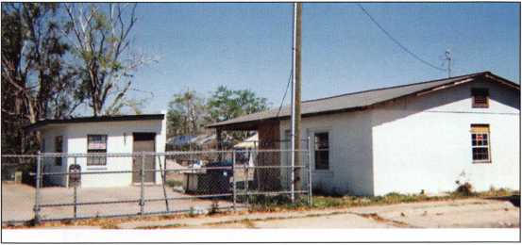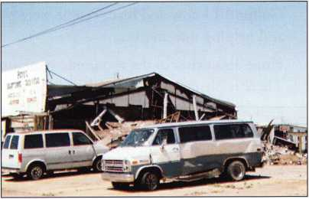

ers like Sinatra and Remains of Hancock Lock and Key

Monroe, and some infa-  
mous personalities such

as reputed mob figure Carlos Marcello, was no more.

The front facade which read “The President”, the casino that had purchased it, still stands but all of the rooms, the cottages, are gone. Across from the hotel, the marina was also destroyed. The marina was where the casino once stood. The tidal surge took the casino and moved it some west and deposited it on top of a two-story hotel in the parking lot of the Coast Coliseum.

Block Building that was front of my family  
two-story home; building stands, home gone

and Biloxi’s  
Back Bay are  
now just con-  
crete pilings  
rising from  
the depths  
with no road-  
way atop  
them. Picture  
a World War  
II movie or  
similar film

that shows the

detonation of an atomic bomb. You can see the explo-  
sion first. Then wave upon wave spreads from the center  
of the blast to level the surrounding area. This is how  
Gulfport appears.

East end of Pete's Electric  
where lock shop was

Keynotes • May 2006

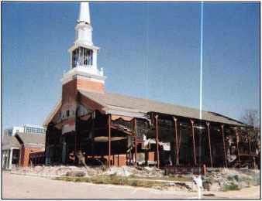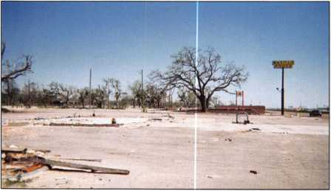

rebuilding their  
lives. At every turn  
I saw people, rela-  
tives or neighbors  
perhaps, measur-  
ing and cutting  
materials, cleaning  
up their yards and  
properties. In one  
neighborhood,  
there was a yard  
with several tables

that appeared to hold dishes and pots of wonderful south-  
ern cooking I miss so much: shrimp, crawfish, corn, bell  
peppers and surely fried chicken. There must have been 20  
or more people milling about waiting to eat and surveying  
the new wall that had just been constructed on the side of  
the house. It reminded me of an old-fashioned country

barn

First Baptist Church

raising. This is still the

Barren trees, empty slabs

Gulfport I know and love. People were pulling together and helping one another.

Hope also exists in the economic structure of the area. There is plenty of work available due to the number of people that left and did not return. Due to the plans for the areas rebirth there will be years of cleanup and rebuilding which will directly equate to more jobs and higher wages.

Though the trip had been emotional for me, it had also renewed my faith in human nature and our drive to sur­vive. Another storm may very well destroy what is left or destroy what gets rebuilt, but this is home and the good people of the Mississippi Gulf Coast will not let it die. Though I keep thinking about how my past has been affected, the thing that replaces that feeling is how the folks living along the coast just take it in stride, thankful for what they do have; each other.

POST SCRIPT

I have had the honor of writing many articles over the years for Keynotes and what I believe sets it apart from the other industry magazines is that Keynotes never resorts to fluff stories not directly related to our profession. This arti­cle started out as simply a journal for myself as therapy for what I had seen. It helped to write it down and get it out of my system. But as I wrote more and more, it dawned on me that it really did have something to do with our busi­ness. It was about the ability those of us that were not directly affected have to help change the lives of those that were. There are a multitude of locksmiths in the New Orleans and Gulf Coast areas that now have nothing. They want to get back to work but have nothing to work with or their employers are not coming back to the area. We have a golden opportunity to help by sending equipment, supplies and yes money to ALOA which has set up a fund for aiding these folks. We also have the opportunity to hire skilled employees that can help our business. Maybe we do not have to offer materials or money but perhaps contact an area locksmith and over a long weekend, help them with cleanup or rebuilding their shop or home. Many are able to work but do not have the time for such activities because it is extremely busy for them in the area.

I once again want to thank ALOA and the Louisiana- Mississippi Locksmiths Association for allowing me to be a part of the rebuilding process and giving me the chance to see and come to grips with my past and the Gulf Coast’s future.

A Side Note about Lou-Miss and ALOA

The Board of the Louisiana Mississippi Locksmiths Association had a very successful outing with its Spring 2005 Convention and was looking forward to the Fall 2005 show. Fate had that show scheduled in Biloxi a couple of week­ends after Katrina’s arrival. Needless to say, it was postponed and plans immediately started for Spring 2006.1 have to say from a personal standpoint that I have nothing but the greatest admiration for each member of the Board of Directors of the Louisiana Mississippi Locksmiths Association and the Education Department, specifically David Lowell, of ALOA. It was decided that the show should definitely go on and should be as close to the affected area as possible to assist those in the most need. ALOA pitched in by providing free education for the show so those that suffered losses would not miss out on education because of financial hardship. Lou-Miss agreed and provided these classes free to attendees from the affected area. To all of you; Bill, Johnny, Merlin, Lee, George, CD, David, you are my heroes. You all exemplify the standards that the founding fathers of the Lou-Miss organization set forth for us and I could not be prouder to be a member of Lou-Miss and ALOA. Thank you.



Keynotes • May 2006

ALOA Members Donate to Storm-struck Locksmiths

by C.D. Lipscomb CML, CPS

At the annual membership business meeting for the Lou-  
Miss Locksmith Association, President Bill Cooper, CRL  
warmly thanked the members of the Associated  
Locksmiths of America, who generously donated equip-  
ment and supplies for locksmiths damaged by last falls  
storms along the gulf coast.

President Cooper described ALOA as a “partner” to the  
Lou-Miss Association. He stated that ALOA has attended

every Lou-Miss con-  
vention since the first  
one and has always  
been there whenever  
the need arose. He  
indicated that the  
first call of assistance  
that he received after  
Hurricane Katrina  
was David Lowell of  
ALOA wanting to

know how ALOA could help.

A van load of ALOA member-donated key machines, hand tools, pin sets, code books, and other reference material was delivered to the convention in Hammond, LA from the ALOA headquarters by South Central Regional Director, C.D. Lipscomb. These donated material, tools and machines were distributed by the Lou-Miss board members and ALOA directors, Bill Smith and C.D. Lipscomb to deserving area locksmiths. Two recipients had their shops flooded or blown away. Another recipient of a $500 ALOA cash grant had lost the entire contents of his shop. Others who had suffered damage had their ALOA dues rebated for 2006 and class fees rebated by the Lou-Miss Association. The ALOA-donated door prize of a full convention educational package was won by yet anoth­er Katrina storm victim.

President Cooper thanked ALOA Regional Directors, Bill  
Smith, and C.D. Lipscomb and ACE Instructor, Jim  
Hancock for donating their time to teach classes at the  
convention and helping to make the 2006 convention one  
of the best in recent memory. He also thanked the many  
vendors there for their donations , attendance and help.  
Attendance in members, students, and vendors was dra-

matically up at this convention. The trade show was very

well attended this  
year. ALOA’s booth  
saw many applica-  
tions for membership  
and renewal filed.

All in all, the show  
was a great success.

It is of note that  
Gulf Coast lock-  
smiths are a hardy,  
determined and self-

sufficient lot. In an area characterized by many people  
demanding aid, none of these people asked for help. This  
was in spite of some severe losses suffered by many of  
them. Those that needed help were reluctant to ask for it.

It took quite a bit of prying and investigation to find peo-  
ple who deserved and needed help. Most, when asked,  
said something to the effect “Yeah, we got torn up a bit,  
but we are getting by”. For those that received donations,  
the gratitude was quite evident. More than one person was  
moved to tears when presented with much needed tools or  
donations. Many “Blessings and Thanks” were offered in  
return. Lou-Miss 2006 was a great example of locksmiths  
taking care of their own. This is what ALOA does.

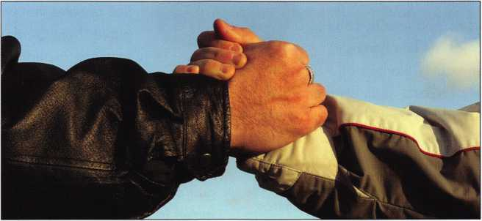

Gardall Safe Corporation

Gardall Safe Corporation has been manufacturing premium  
quality fire rated and burglary rated safes since 1950.  
Gardall has always had its manufacturing operations in  
Syracuse, New York although, they expanded to the West  
Coast with the acquisition of Los Angeles based Horizon  
Safe Manufacturing in the mid 1990's. Gardall has a long  
history in the safe industry and they have seen many com-  
petitors fall by the wayside or be gobbled up in a consoli-  
dation within the competitive safe marketplace. With its  
strong commitment to customer service and pre-

mium quality, Gardall is very optimistic that  
they will be a viable safe manufacturer for  
many years to come.

Gardall's strongest marketplace is in medium  
level security for both residential and commer-  
cial customers. On the residential side safe  
applications include homes, apartments, con-  
dominiums, vacation homes, mobile homes,  
residence halls and even boats. Storage of

personal belongings like passports, birth certificates, insur-  
ance documents, car titles, or residential deeds, are just a  
few of the special items people put in safes. These items  
may not have high cash values but they are a heartache to  
replace when they are lost. In addition, many items with  
cash value are also stored in safes like jewelry, cameras,  
family heirlooms, coin collections, handguns, silverware or  
cash itself.

Commercial applications are wide and varied and may not  
be I imited to cash. Important business documents, as well  
as business records, can be protected in a Gardall safe.

Fire, burglary and computer data storage are just some of  
the classifications used by dealers when they discuss safe  
requirements with commercial customers. In addition, the  
demand for depositories used for dropping cash during  
business hours is increasing. Some depositories are big  
enough to accommodate cash tray storage within them as  
an extra feature. One important feature that is readily  
becoming a standard in many commercial applications is  
the push button electronic lock. Today's sophisticated elec-  
tronic locks offer features like multiple users, audit trail, time  
delay and easy programming of combinations. Many deal-  
ers are making money by converting existing combination  
locked safes to electronic locked safes using these features.

The security industry has continued to grow especially since

the tragedy that occurred on September 1 l^1. With this  
growth there has been an introduction of many new prod-  
ucts that are sold at many new locations that have not  
always been part of the traditional security marketplace.  
Premium quality products, like those manufactured by  
Gardall, are under attack from low-end manufacturers with  
price as their only selling feature. Their after sales techni-  
cal support, customer service and warranty service are just

not available to dealers or end users. To com-  
pete with this new breed of safe manufacturer,  
Gardall decided that it needed to expand its  
traditional product offering to include some  
lower priced units than the typical $500 to  
$600 list price safes. Five years ago Gardall  
began exploring the possibility of creating a  
line of safes that would combine design tech-  
niques from Gardall's 50 plus years of manu-  
facturing expertise and low cost imported  
designs that were already available. The end

result has been many new products, made to Gardall's  
specifications, that in some cases carry UL labels for fire  
and burglary protection at costs far under the cost of  
domestically produced products. Gardall has continued to  
guarantee the quality of these safes as if they were pro-  
duced in Syracuse, New York. The end result has been  
that Gardall dealers now have products to sell that cover  
all spectrums of the safe market place from a low list price  
of $205 to a high price of $17,300.

Gardall will continue to produce premium quality safes in  
both Syracuse and Los Angeles. In addition, we will keep  
improving our off shore product quality, selection, and  
offering, although, all of our dealers and customer's realize  
the core success in Gardall's safe business is its customer  
service and support after the sale.

For further information about Gardall Safe Corporation  
please visit our website at [www.gardall.com](http://www.gardall.com). If you are  
already a Gardall dealer make sure you take advantage of  
the free dealer listing on the web site or call us at 800-722-  
7233 to be added as a dealer.

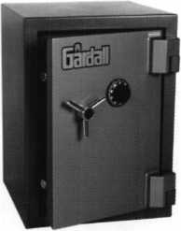

Keynotes • May 2006

Gardall Fireproof Safes

**_ mi«m** Quality at

Rei onable Prices

Retail List $315

Retail List $425

U.L. 350° 1 Hour  
Fire Label

U.L. 350° 1 Hour  
Fire Label

Both models feature:

1. Pull out drawer to store small items
2. Center bolt down hole w/anchoring hardware
3. 6 Digit electronic push button lock with 2 combo capacity
4. UL 1 Hour Fire Label
5. Extremely durable powder coated finish

Gardall Dealers: Check the accuracy of your listing on our website  
at [www.gardall.com](http://www.gardall.com). If we missed you or we need to correct your  
information please contact Customer Service at 800-722-7233.

To place an order contact your local Gardall distributor  
or call 800-722-7233 for the distributor nearest you.

“The Locksmith’s Safe Company”

Birial'

PREMIUM QUALITY SAFES

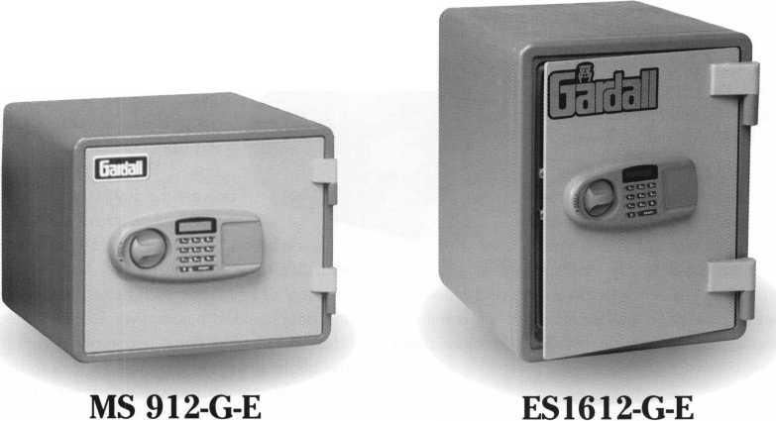

Need a Key Machine? Bianchi Has You Covered

For over 235 years, the Bianchi family has been a constant pio-  
neer in the locksmith industry, beginning in the Cadore Valley of  
Northern Italy in 1770. Through five generations, the company  
evolved into a full-line manufacturer of keys and key cutting  
machines and began distributing worldwide in the mid 1900's.  
Bianchi products first landed in North America in the early 1980's  
and the first independent presence in the market came in 1989  
when Massimo Bianchi expanded his Italian company, Silca, into  
the US. Following mergers in 1997 with the Canadian Unican

Group and 2001 with the llco/Kaba Group,

Massimo Bianchi left the organization and re-  
emerged in 2002 with the acquisition of  
KeyLine & Kema, Italian manufacturers of keys  
and key cutting machines and then followed  
with Bianchi USA, Inc. in 2003.

Since its inception, Bianchi USA, Inc. has experi-  
enced tremendous growth. Beginning with just 3

key machines, Bianchi has expanded into transponder  
keys, cloning tools and a growing key machine line,

including high security key machines, code cutting and automatic  
machines. The newest products in the key machine line are the  
Bianchi 095 Automatic and the Bianchi 106 Semi-Automatic and  
are discussed below.

The Bianchi 095 Automatic offers quality, durability and preci-

sion key cutting; all things that one comes to expect from a  
great key machine. The 095 is the first key machine made

in the USA and the first automatic key machine  
offered by Bianchi USA, Inc. The 095 features a  
heavy duty cast aluminum body which reduces  
vibration and noise improving both cut consisten-  
cy and cutter life. The 39 pound 095 boasts a  
high quality drive belt which powers the single  
speed motor and 63mm high speed steel cutter  
as well as an independent soft touch de-burring  
brush.

The 095 is equipped with many features that enhance the quality of the machine as well as the experience for the user. Four-way reversible jaws allow for easy adjustment to accommo­date a variety of key types such as residential, single sided auto­motive and double sided automotive. The micrometric tracer adjustment features a dual axis gauging system for quick, easy and accurate depth calibration; this is especially useful in the case of worn keys. In order to keep a cleaner work area, the base of the machine features a slide-out removable chip tray which col­lects falling chips.

Designed specifically for the retail market, the safety features offer an added security when operating the machine. The automatic operation is controlled by a 'safety start' feature which uses two momentary push buttons for start-up thus eliminating the possibility of your hands being near the cutter during operation. Another important safety feature is the automatic cutter shut-off which stops cutter movement when the key is cut and the carriage drops

down. The carriage movements remain smooth and accurate due  
to slide-ways in the casting and a carriage stop prevents the jaws  
from accidentally contacting the cutter. Finally, a large transparent  
cutter shield improves viewing during cutting and prevents loose  
chips from going astray. This is all to ensure the safety of the user

and the machine while also making key cutting as user-friendly as

possible. The 095 comes complete with a user's manual, tool kit

and one year warranty as well as a technical support number if

needed.

The Bianchi 106 Semi-Automatic was introduced early

this year and embodies true Italian innovation and

design featuring a sleek but heavy duty cast iron  
body which reduces vibration and noise improv-  
ing both cut consistency and cutter life. The 65  
pound 106 boasts a high quality drive belt which  
powers the single speed motor and 80mm high

speed steel cutter as well as a separate soft touch

de-burring brush. The 106 is also equipped with four-way  
reversible jaws, which allow for easy adjustment to accommodate

a variety of key types such as residential, single sided automotive  
and double sided automotive. The spring-loaded carriage, which

rides on roller bearings, is combined with the unique one piece  
jaw alignment system to provide smooth and easy movement. The  
micrometric tracer adjustment allows for quick, easy and

accurate depth and space calibration. Ergonomic han-  
dles and levers ease operation and give this sturdy  
machine a polished look.

Performance sets the 106 apart from the rest, but  
the safety features enhance the experience for the  
user. An overhead neon light comes standard, illu-  
minating the key cutting area, while a fold down

magnifying glass aids in getting a closer look at  
hard to see cuts. The base of the machine fea-  
tures a large removable chip tray which collects  
falling chips and the small tray at the top of the

machine is available to store spare keys, tip stops  
or cut keys for easy access. A large transparent cutter shield  
improves viewing during cutting and prevents loose chips from

going astray. Finally, the newest safety feature - a locking car-

riage - prevents accidental carriage release. When ready to cut a  
key, the user simply squeezes the lever while releasing the car-  
riage eliminating the possibility of the jaw 'jumping' up. The car-  
riage will also not release until the key gauges have cleared.  
Overall, the 1 06 is a solid, hard working machine that will pro-

vide years of worry free use and comes complete with a user's

manual, tool kit and one year warranty as well as a technical sup-  
port number if needed.

Finally, in addition to these new machines, Bianchi offers the 101

Manual, 102 & 104 Semi-Automatic, 303 High Security and BD

Laser Code Cutting Machine as well as the Repli-Code 7 Cloning

Tool and a variety of transponder keys. For more information on

Bianchi key machines or any Bianchi products, call 800-891-  
2118 or visit [www.bianchi](http://www.bianchi) 1770usa.com.

Keynotes • May 2006

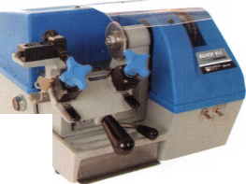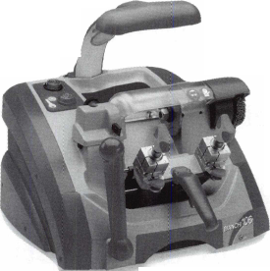

Don’t just duplicate...

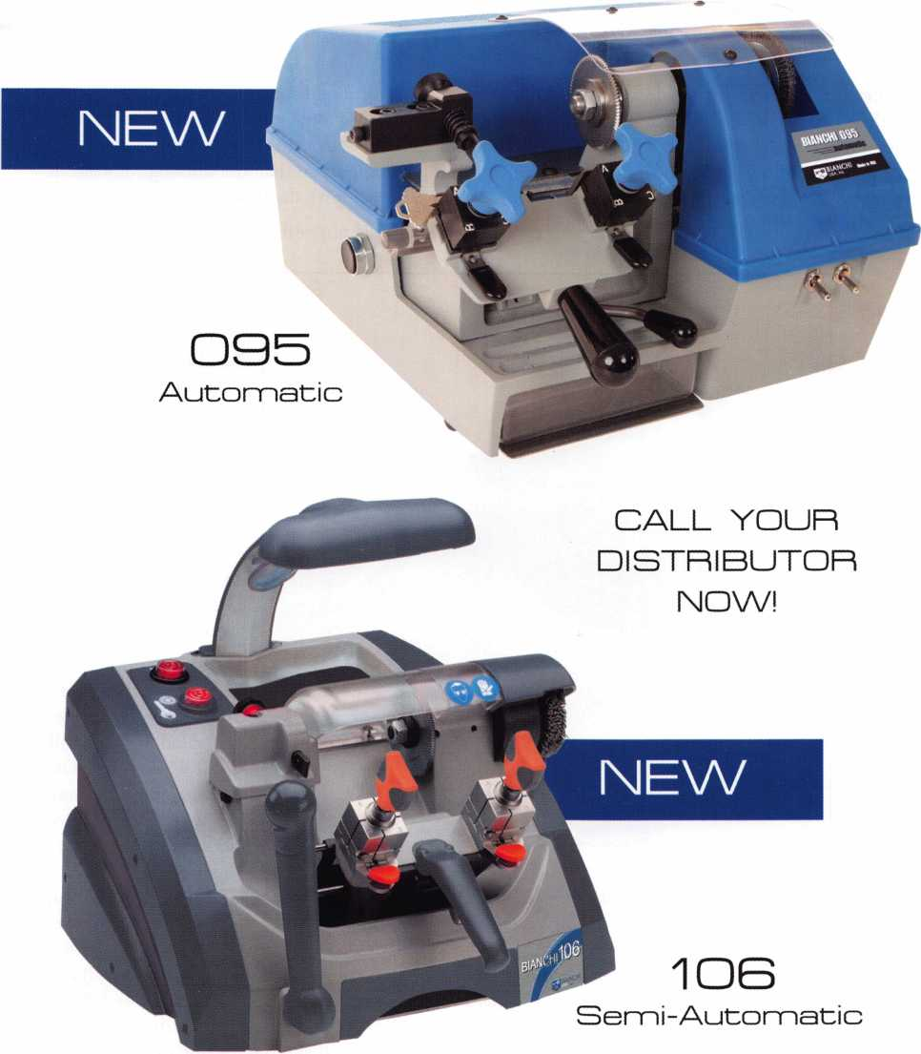

**800.89t.2118**

**wvnM.bianchi1770usa.com**

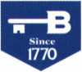

BIANCHI

**USA, Inc.**

A BIANCHI ngOGROUB Company

**IN DVA"**

Are You A Professional?

by Claire L. Cohen, CML



Some people think that they become a “professional” simply  
by acquiring a degree. Others disagree and say that a piece of  
paper or a certificate does not create a professional. They  
believe he or she must be a person who is well-trained, good  
at their work and dependable. What is your image of a true  
professional in the security industry?

Professionalism is a goal for  
everyone in business,  
whether employed by a large  
company or a small one.

The first step to making  
yourself a “professional” is  
to decide you ARE a profes-  
sional! Anything that you  
do should be done skillfully  
with high-quality standards.

A professional develops a  
frame of mind that whatever  
is accomplished is done as a  
specialist.

Coupled with the profes-  
sional mindset, we need to  
project a confident and  
qualified image. This  
reflection can be measured  
by how our place of busi-  
ness looks, how we look,  
and how we sound.

Appearance is reality. Visual  
signals send powerful infor-

mation to the consumer and often communicate more than  
words or the sound of the voice. Start with the look of your  
place of business, whether it is a storefront or service vehicle.  
The area a customer views should be neat and clean. Every  
element from business cards to displays can create a measure  
of confidence in you, your company and the quality of the  
goods you sell and the services you provide.

Different workplace settings dictate the style of dress. A casual  
style of dress or uniform should not compromise our profes-  
sionalism. Aside from clean attire, it is the way we carry our-  
selves which is more important than the clothing we wear. It  
is critical attempt to put forth the image of success.

Feedback is not limited physical surrounding of our work-  
place or the clothing we

wear. Our image is pro-  
jected thorough our  
body language. A firm  
handshake, looking  
someone directly in the  
eye and good posture  
can convey an image  
confidence.

Communication also  
shows how professional  
we are. Do we take time  
to explain something to  
our customers, and co-  
workers?

We are not always able  
to have visual contact  
with customers. Some  
generated business will  
occur without it. The  
verbal communication  
we project via the tele-  
phone can insure that  
the prospective client

sees a professional. How we sound and the tone of our voice  
can create a range of impressions. Wnh the absence of the  
visual information, the listener can only rely on your confi-  
dence in the products you sell and quality of service, choice  
of words and quality of your speaking voice. Think before  
you speak, become a good listener, and pay attention to the  
customer. How we sound and the tone of a voice can cre-  
ate or discourage sales, (continued on pg. 34)

Keynotes • May 2006

This year we’re back in LEXINGTON for the 150th Anniversary of Sargent & Greenleaf.

***THE RACE STARTS HERE***

Keeping up with the latest the industry has to offer has never been this important - or this FUN! When it comes to learning about the latest in safes and vaults, time

**SAFETECH**



**LEXINGTON’S**

is of the essence. SAFETECH 2007 fea­tures an all-new menu of classes, covering every

**READY.**

**ARE YOU?**

safe topic on the globe.

***OUR SAFETECH 2007 SPONSORS!!***



**SARGENT AND GREENLEAF®**

**MARCH 5th thru MARCH 10th, 2007**

**LEXINGTON**

**KENTUCKY**



An Amateur...

* skips the learning process
* assumes what others need and want
* is sloppy in appearance and speech
* is confused and distracted
* ignores or hides mistakes
* tries to get out of difficult work
* has a messy, confused or dirty work area
* is surrounded by unfinished work
* produces just enough to get by
* produces the minimum required and looks for the

easy way out

* earns low pay and feels it’s unfair
* is content with what he/she already knows
* has an uncertain future

A Professional...

* learns every aspect of the job through many

different paths

* carefully researches what is needed and wanted

and what is available

* looks, speaks and dresses like a qualified expert
* is focused and clear-headed
* recognizes mistakes and corrects them
* views difficult work as a challenge
* keeps his or her work area clean, neat and orderly
* completes projects as soon as possible in order to

go onto the next project

* produces more than expected
* always looks for the right product for the job and

strives for a high-quality service

* is rewarded with higher pay
* is constantly learning about every aspect of

the industry

* has a promising career future

(Continued from pg. 32)

Are you an amateur or a professional?

A professional attitude gets reflected in the job that is done.

It should reflect care and ability, along with confidence. Whenever you work, you have the ability to refine these visu­al, verbal and vocal elements to convey an image of power, competence, clarity and success.

Professionalism is an attitude toward our work and it has to be acquired over a period of time. It is also the only way to survive in today's world.



Keynotes • May 2006

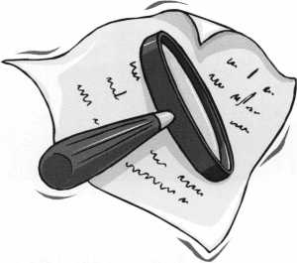

KEY CODE SERVICE

With proper ID and security clearance

we can get codes for most cars.

Fax us at 1 -800-695-6810  
or call 1-800-741-4764  
for more information.

Hello, I'm Doug Jameson of Jameson Code Services. We would like to try and make your  
business just a little easier when you make a key. We can furnish a key code to you for  
almost all cars. There is no charge should the code we provide not work. We can have most  
codes back to you within 30 minutes. Some codes are even quicker such as Ford and  
Toyota. We furnish a pin number for Chryslers, also brake codes and immobolizer codes  
for Hondas and Acuras. We have been in the key code business since 1995 and learn a lit-  
tle more everyday. We are open Monday thru Friday 8:30 a.m. to 6:00 p.m. If you have a  
real emergency after these hours or on the weekend my pager number is 972-319-8782.  
There are a few brands I can get a code for after hours. All codes are $15.00. This includes  
a vat number if needed. The $15.00 also includes the pin number, brake code and  
immobolizer code. Corvettes are a special category as the vat numbers are not often avail-  
able. We would appreciate your input and welcome suggestions for improving our service.  
Give us a call at 214-630-0477 to set up your account or to have any questions answered.  
Looking forward to servicing all locksmiths. Fords and Chryslers within 15 minutes!

We are accepting applications from ALOA Members only.

Fax us at 1-800-695-6810  
or call 1-800-741-4764

**Classifieds**

EMPLOYMENT

STORE MANAGER WANTED

Opportunity in South Orange County, California for person with extensive locksmith and/or distribu­tor experience. Position provides salary, helath insurance, vacation and holidays. Send resume to: 949-492-0246 or call Tony's Locksmith at 949-492-5731.

LOCKSMITH WANTED

$3670.81-$4461.90 per month. The City of Chula Vista (San Diego's County second largest city) is currently seeking to fill their Locksmith position that will plan, implement and mainitain a master lock and key program including computer based acccess control systems throughout the city build­ings. This position has full benefits and will receive 16% COLA increase over the next four years. City of ChulaVista, 276 4th Ave, Ca. 91910 [www.chulavistaca.gov](http://www.chulavistaca.gov) or 619-691-5096 for more info. Apply immediately!

WANTED TO BUY/SELL

BUSINESS FOR SALE

Turn key lock shop business, over 20 years same location. In the most enchanting and diverse region on Earth. Port Angeles, Wa. where the Olympic Mountains meet the Sea. $170,000 Includes all equipment, inventory, tools, cus­tomer list and training. Call Harriet at Windermere

Real Estate 1-800-786-1456 ext.

30

BUSINESS FOR SALE

In south-central Wisconsin, well- established,^ years in the same location. One person shop with room to expand.Business has many commercial and residential accounts. Includes service van,equipment,and invento- ry.$85,000 takes all. Owner wish­es to retire-will help with transition. CALL (608)325-5011 OR EMAIL: [lockshop@tds.net](mailto:lockshop@tds.net)

SMALL MOBILE LOCKSMITH BUSINESS FOR SALE

Established 1979 with solid client base. Excellent opportunity for someone who is wanting to relo­cate and start a business. Located in sunny Albuquerque, NM. We're ready to retire!!!

Commercial Safe & Lock 475-58th St. NW Albuquerque, NM 87105 505-836-9503

FOR SALE

Locksmith equipment and inventory. Machines, keys, locks, tools - all for one low price - due to health, must sell. ALOA member. Forest E. Long, 970-854-3301

WANTED TO BUY

Want to purchase old and dis- countinued Schlage Decorative Hardware in both Dragon and La Fontaine designs. Any assistance would be gladly welcome. ALOA member. Peter Field, P.O. Box 104, Salem, VA, 24153. Tel. 540- 380-5000. Fax. 540-380-1657.

Classified Advertising Policy

Classified advertising space is provided free of charge to ALOA members and for a fee of $2.00 per word, $40.00 minimum for non members. Classified ads may be used to advertise used merchandise and overstocked items for sale, "wanted to buy" items, business opportunities, employment opportunities/positions wanted and the like. Members or non members wishing to advertise services or new merchandise for sale may purchase a "Commercial Classified Ad" for a fee of $4.00 per word with a minimum of $ 100.00. Each ad will run for two issues. For blind boxes there is a $ 10.00 charge for members and non members. All ads must be submitted in writing to the Advertising Sales Department via fax at 817-645-7599 or through an email to [adsales@aloa.org](mailto:adsales@aloa.org) by the fifteenth of the month two months prior to issue date. ALOA reserves the right to refuse any classified adver­tisement that it deems inappropriate according to the stated purpose of the classified advertising section.

Features & Benefits

* Industrial Strength Combination Lock!
* Resists Hammer and Re-bar Attacks!
* Hardened Steel Full Metal Jacket!
* Hardened Steel Full Metal Jacket Shroud!
* Weather Resistant Black Electrocoating!
* 7/16” Chrome Plated Molybdenum Shackle!
* Inside Shackle Clearances: 1 ” and 2”!
* Shackle Pull Strength: 2,750 pounds!
* All Brass Inner Mechanism!
* Four All Brass Dials!
* 10,000 Changeable Combinations!
* Quick Delivery: Shipped from Stock!

***nation Padlock***

***Combination***

**Security Products**

**A Division of The Eastern Company**

**301 West Hintz Road Wheeling, IL 60090 Telephone: 800.733.8588 Fax: 847.537.1881 [www.cclsecurity.com](http://www.cclsecurity.com)**

r *PlodUClS*

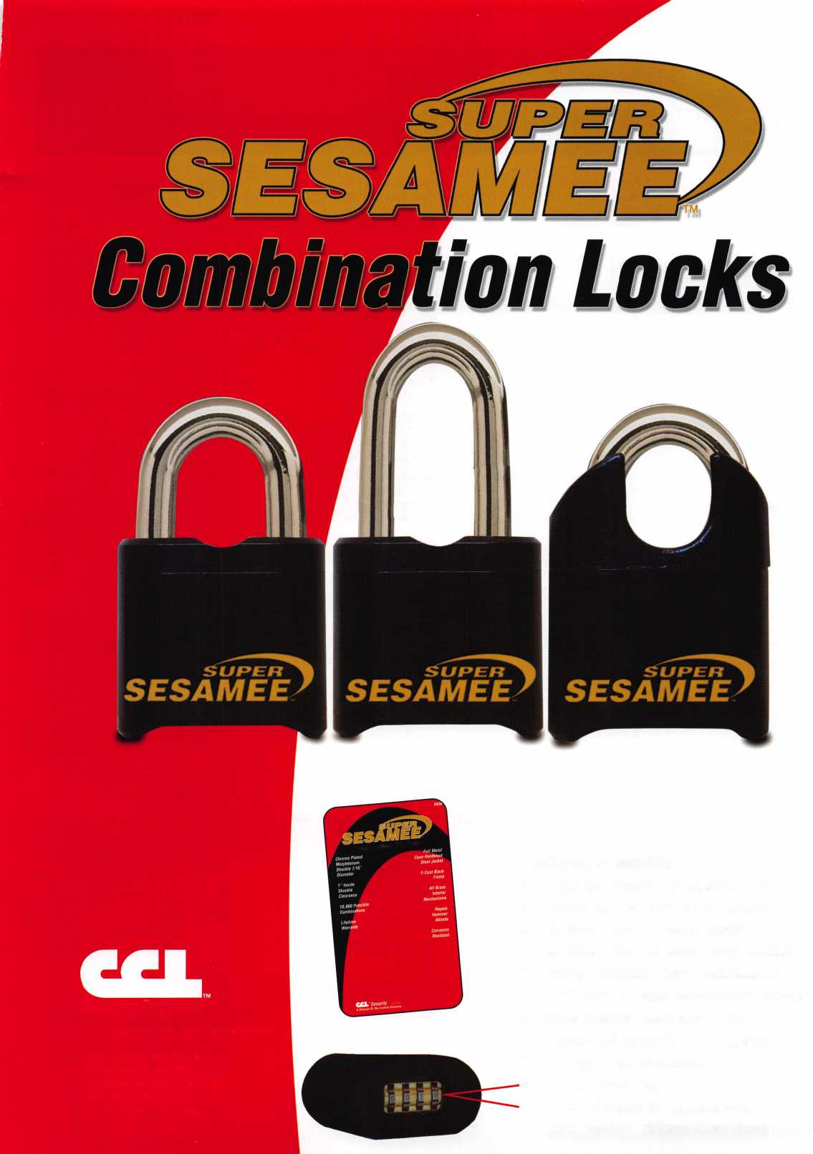

Distributor

**1 st In Hardware, Inc.**

Phone: Phone: 410-646-9900  
Fax: 410-646-0045  
www. 1 stinhardware.com

**ADEL Fingerprint Technology, LLC**

Phone: 909-595-1222  
Fax: 909-595-1667

**Accredited Lock Supply Co.**

Phone: 800-652-2835  
Fax: 201-865-2435  
[www.acclock.com](http://www.acclock.com)

**Andrews Wholesale Lock Supply**

Phone: 717-272-7422  
Fax: 717-274-8659  
[www.andrewslock.com](http://www.andrewslock.com)

**Boyle & Chase Inc.**

Phone: 800-325-2530  
Fax: 800-205-3500  
[www.boyleandchase.com](http://www.boyleandchase.com)

**Clark Security Products**

Phone: 858-974-6740  
Fax: 858-974-6720  
[www.clarksecurity.com](http://www.clarksecurity.com)

**Cook's Building Specialties**

Phone: 505-883-5701  
Fax: 505-883-5704

**Dire's Lock & Key Company**

Phone: 303-294-0176  
Fax: 303-294-0198

**Direct Security Supply, Inc.**

Phone: 800-252-5757  
Fax: 800-452-8600

|  |  |  |  |
| --- | --- | --- | --- |
| ipl  \ a s  H | > s o c  m e m b | •  I  e | a t e  r s |
| H.L. Flake Co. | Phoenix Safe International LLC | | Manufacturer |
| Phone: 800-231-4105 | Phone: 765-483-0954 |  |  |
| Fax: 713-926-3399 | Fax: 765-483-0962 |  | A & B Safe Corporation |
| [www.hlflake.com](http://www.hlflake.com) | www. phoen ixsafeusa .com |  | Phone: 800-253-1267 |
| Hans Johnsen Company | Positive Identity Solutions |  | Fax: 856-863-1208 |
| Phone: 214-879-1550 | Phone: 704-663-1175 |  | [www.a-bsafecorp.com](http://www.a-bsafecorp.com) |
| Fax: 214-879-1530 | Fax: 704-660-1301 |  | ABUS Lock Company |
| [www.hjc.com](http://www.hjc.com) | [www.pids-usa.com](http://www.pids-usa.com) |  | Phone: 800-352-2287 |
| Hardware Agencies, Ltd. | RA-Lock Company |  | Fax: 602-516-9934 |
| Phone: 416-462-1921 | Phone: 972-775-6301 |  | [www.abus.com](http://www.abus.com) |
| Fax: 416-462-1922 | Fax: 972-775-6316 |  | Access Security Products Ltd. |
| [www.hardwareagencies.com](http://www.hardwareagencies.com) | [www.ralock.com](http://www.ralock.com) |  | Phone: 905-337-7874 |
| IDN Incorporated | Security Distributors Inc |  | Fax: 905-337-7873 |
| Phone: 817-421-5470 | Phone: 800-333-6953 |  | [www.access-safe.com](http://www.access-safe.com) |
| Fax: 817-421-5468 | Fax: 612-524-0166 |  | Adams Rite Mfg Company |
| [www.idn-inc.com](http://www.idn-inc.com) | Security House |  | Phone: 800-872-3267 |
| Instant Hardware Delivery, Inc | Phone: 905-669-5300 |  | Fax: 800-232-7329 |
| Phone: 800-355-1107 | Fax: 905-660-6313 |  | [www.adamsrite.com](http://www.adamsrite.com) |
| Fax: 800-663-8518 | [www.securityhouselock.com](http://www.securityhouselock.com) |  | Adesco Safe Mfg. Company |
| Infermountain Lock & Supply | Security Lock Distributors |  | Phone: 800-694-9340 |
| Phone: 800-453-5386 | Phone: 800-847-5625 |  | Fax: 562-408-6427 |
| Fax: 801-485-7205 | Fax: 800-878-6400 |  | [www.adesco.com](http://www.adesco.com) |
| [www.intermountainlock.com](http://www.intermountainlock.com) | [www.securitylockdistributors.com](http://www.securitylockdistributors.com) |  | Adrian Steel Company |

**International Electronics, Inc**

Phone: 800-343-9502 Fax: 617-821-4443

**Jo Van Distributors**

Phone: 416-288-6306 Fax: 416-752-8371 [www.jovanlock.com](http://www.jovanlock.com)

**Lockmasters, Inc.**

Phone: 859-885-6041 Fax: 859-885-7093 [www.lockmasters.com](http://www.lockmasters.com)

**Discount Key Machines.Com/Busch Lacks Company**

Phone: 800-332-8724

Fax: 407-363-4666

Phone: 800-288-0801  
Fax: 305-949-3619

**Southern Lock and Supply Co.**

Phone: 727-541-5536 Fax: 727-544-8278 [www.southernlock.com](http://www.southernlock.com)

**Stone & Berg Wholesale**

Phone: 800-225-7405 Fax: 800-535-5625

**Streetwise Security Products**

Phone: 252-830-5577 Fax: 252-830-5542

**The Locksmith Store Inc.**

Phone: 847-364-5111 Fax: 847-364-5125 [www.locksmithstore.com](http://www.locksmithstore.com)

Phone: 800-677-2726 Fax: 517-265-5834 [www.adriansteel.com](http://www.adriansteel.com)

**Advanced Diagnostics USA Inc**

Phone: 650-876-2020 Fax: 650-876-2022 [www.ad-mvp.com](http://www.ad-mvp.com)

**Alarm Controls Corporation**

Phone: 631-586-4220 Fax: 631-586-6500 [www.alarmcontrols.com](http://www.alarmcontrols.com)

**All Five Tool Company, Inc.**

Phone: 860-583-1691 Fax: 860-583-4516 [www.all5tool.com](http://www.all5tool.com)

**Doyle Security Products**

Phone: 800-333-6953 Fax: 612-521-0166 [www.doylesecurity.com](http://www.doylesecurity.com)

**Dugmore and Duncan, Inc.**

Phone: 888-384-6673 Fax: 888-329-3846

**E. L. Reinhardt Co., Inc.**

Phone: 800-328-1311 Fax: 651-481-0166 [www.elreinhardt.com](http://www.elreinhardt.com)

**Ewert Wholesale Hardware**

Phone: 800-451-0200 Fax: 708-597-0881

**Foley-Belsaw Company**

Phone: 800-821-3452 Fax: 816-483-5010 [www.foley-belsaw.com](http://www.foley-belsaw.com)

**Fried Brothers Inc.**

Phone: 800-523-2924 Fax: 215-592-1255 [www.fbisecurity.com](http://www.fbisecurity.com)

**Locksmith Ledger International**

Phone: 847-454-2700 Fax: 847-454-2759 [www.lledger.com](http://www.lledger.com)

**McDonald Dash Locksmith Supply**

Phone: 800-238-7541 Fax: 901-366-0005 [www.mcdonalddash.com](http://www.mcdonalddash.com)

**Monaco Lock Co.**

Phone: 800-526-6094 Fax: 800-845-5625 [www.monacolock.com](http://www.monacolock.com)

**NLS Lock Supply Dba Nevada Lock S**

Phone: 702-737-0500 Fax: 702-737-7134

**Omaha Wholesale Hardware**

Phone: 800-238-4566 Fax: 402-444-1664 [www.omahawh.com](http://www.omahawh.com)

**Timemaster Inc.**

Phone: 859-259-1878 Fax: 859-255-0298 [www.time-master.com](http://www.time-master.com)

**Top Notch Distributors, Inc.**

Phone: 800-233-4210 Fax: 800-854-4146 [www.topnotch.bz](http://www.topnotch.bz)

**Turn 10 Wholesale**

Phone: 800-848-9790 Fax: 800-391-4553

**U.S. Lock Corp.**

Phone: 800-925-5000 Fax: 800-338-5625 [www.uslock.com](http://www.uslock.com)

**Wilson Safe Company**

Phone: 215-492-7100 Fax: 215-492-7104 [www.wilsonsafe.com](http://www.wilsonsafe.com)

**American Security Products**

Phone: 909-685-9680x2013 Fax: 909-685-9685 [www.amsecusa.com](http://www.amsecusa.com)

**BWD Lockcraft**

Phone: 973-728-3707 Fax: 973-728-3731 [www.bwdautomotive.com](http://www.bwdautomotive.com)

**Bianchi USA, Inc.**

Phone: 800-891-2118 Fax: 216-803-0202 [www.bianchil770usa.com](http://www.bianchil770usa.com)

**Buddy Products**

Phone: 312-733-6400 Fax: 312-733-8356 [www.buddyproducts.com](http://www.buddyproducts.com)

**CCL Security Products**

Phone: 800-733-8588 Fax: 847-537-1800 [www.cclsecurity.com](http://www.cclsecurity.com)

Keynotes • May 2006

i

associate

members

CompX Security Products Phone: 864-297-6655 Fax: 864-297-9987 [www.compxnet.com](http://www.compxnet.com)

**D&D Technologies (USA), Inc.**

Phone: 714-677-1300x292 Fax: 714-677-1299 [www.ddtechusa.com](http://www.ddtechusa.com)

**DETEX Corp.**

Phone: 800-729-3839 Fax: 830-620-6711 [www.detex.com](http://www.detex.com)

**Don-Jo Manufacturing, Inc.**

Phone: 978-422-3377 Fax: 978-422-3467 [www.don-jo.com](http://www.don-jo.com)

**Door Controls international**

Phone: 800-742-3634 Fax: 800-742-0410 [www.doorcontrols.com](http://www.doorcontrols.com)

**Dooricing Inc.**

Phone: 800-826-7493 Fax: 310-641-1586 [www.doorking.com](http://www.doorking.com)

**E-Lock USA**

Phone: 434-589-5913 Fax: 434-589-3738 [www.e-lock-usa.com](http://www.e-lock-usa.com)

**FireKing Security Products**

Phone: 800-457-2424 Fax: 800-896-6606 [www.fkisecuritygroup.com](http://www.fkisecuritygroup.com)

**Framon Manufacturing Company Inc.**

Phone: 989-354-5623 Fax: 989-354-4238 [www.framon.com](http://www.framon.com)

**G-U Hardware Inc.**

Phone: 757-877-9020 Fax: 757-877-9720 [www.g-u.com](http://www.g-u.com)

**HPC, Inc.**

Phone: 847-671-6280 Fax: 847-671-6343

[www.hpcworld.com](http://www.hpcworld.com)

**HY-KO Products Co.**

Phone: 330-467-7446 Fax: 330-467-7442

**Hammerhead Industries, Inc.**

Phone: 805-658-9922 Fax: 805-658-8833

[www.gearkeeper.com](http://www.gearkeeper.com)

**Ingersoll Rand Security Technologies**

Phone: 317-805-5713 Fax: 317-805-5779 [www.schlagelock.com](http://www.schlagelock.com)

**Jackson Corporation**

Phone: 323-269-8111 Fax: 800-888-6855 [www.jacksonexit.com](http://www.jacksonexit.com)

**Jet Hardware Mfg., Co.**

Phone: 718-257-9600 Fax: 71 8-257-0973 [www.jetkeys.com](http://www.jetkeys.com)

**KABA ILCO Corp.**

Phone: 252-446-3321 Fax: 252-446-4702 [www.kaba-ilco.com](http://www.kaba-ilco.com)

**KEY-BAK/West Coast Chain Mfg.**

Phone: 909-923-7800 Fax: 909-923-0024 [www.keybak.com](http://www.keybak.com)

**Keri Systems Inc.**

Phone: 408-451-2520 Fax: 408-441-0309 [www.kerisys.com](http://www.kerisys.com)

**Knaack Manufacturing Co.**

Phone: 800-456-7865 Fax: 815-459-9097 [www.weatherguard.com](http://www.weatherguard.com)

**(Custom Key Inc.**

Phone: 800-537-5397 Fax: 800-235-4728 [www.kustomkey.com](http://www.kustomkey.com)

**LAB Security**

Phone: 800-243-8242 Fax: 860-583-7838 [www.labpins.com](http://www.labpins.com)

**La Gard Inc.**

Phone: 310-325-5670 Fax: 310-325-5615 [www.lagard.com](http://www.lagard.com)

**Lock America, Inc. dba L.A.I. Group**

Phone: 714-373-2993 Fax: 714-373-2998 [www.laigroup.com](http://www.laigroup.com)

**Lucky Line Products, Inc.**

Phone: 858-549-6699 Fax: 858-549-0949 [www.luckyline.com](http://www.luckyline.com)

**M.A.G. Manufacturing**

Phone: 714-891-5100 Fax: 714-892-6845 [www.magmanufacturing.com](http://www.magmanufacturing.com)

**MUL-T-LOCK USA, Inc.**

Phone: 800-562-3511 Fax: 973-778-4007 [www.mul-t-lockusa.com](http://www.mul-t-lockusa.com)

**Major Mfg, Inc.**

Phone: 714-772-5202 Fax: 714-772-2302 [www.majormfg.com](http://www.majormfg.com)

**Maxcess Card Systems Ltd**

Phone: 949-492-5964 Fax: 949-492-0415 www. maxcess-card .com

**Medeco Security Locks**

Phone: 540-380-5000 Fax: 540-380-5010 [www.medeco.com](http://www.medeco.com)

**Mii-Comm Products Co Inc**

Phone: 201-935-8561 Fax: 201-935-6059

**Promet Safe Inc.**

Phone: 859-373-8565 Fax: 877-690-9595

**Protex Safe Co., LLC**

Phone: 818-610-8030 Fax: 818-610-8004 [www.protexsafe.com](http://www.protexsafe.com)

**ROFU International Corp.**

Phone: 253-922-1828 Fax: 253-922-7272 [www.rofu.com](http://www.rofu.com)

**Rutherford Controls Inti Co.**

Phone: 519-621-7651

Fax:519-621-7939

[www.rutherfordcontrols.com](http://www.rutherfordcontrols.com)

**STRATTEC Security Corp.**

Phone: 414-247-3333

Fax:414-247-3564

[www.aftermarket.strattec.com](http://www.aftermarket.strattec.com)

**Sargent & Greenleaf, Inc.**

Phone: 859-885-941 1 Fax: 859-885-3063 [www.sargentandgreenleaf.com](http://www.sargentandgreenleaf.com)

**Sargent Manufacturing Co.**

Phone: 800-727-5477 Fax: 888-863-5054 [www.sargentlock.com](http://www.sargentlock.com)

**Schwab Corp.**

Phone: 765-447-9470 Fax: 765-447-8278 [www.schwabcorp.com](http://www.schwabcorp.com)

**Securifort Inc**

Phone: 819-359-2226 Fax: 819-359-2218 [www.securifort.com](http://www.securifort.com)

**Securitron Magnalock Corp.**

Phone: 775-355-5625 Fax: 775-355-5636 [www.securitron.com](http://www.securitron.com)

**Security Door Controls**

Phone: 805-494-0622 Fax: 805-494-8861 [www.sdcsecurity.com](http://www.sdcsecurity.com)

**Town steel, Inc.**

Phone: 626-858-5080 Fax: 626-858-3393 [www.townsteel.com](http://www.townsteel.com)

**UCA Inc**

Phone: 972-437-4696 Fax: 972-692-7056 [www.ibuttonlock.com](http://www.ibuttonlock.com)

**Videx Inc.**

Phone: 541-758-0521 Fax: 541-752-5285 [www.videx.com](http://www.videx.com)

**YSG Door Security Consultants, Inc.**

Phone: 800-438-1951 Fax: 800-338-0965

Service

Organization

**Allstate Insurance Company**

Phone: 847-551-2181 Fax: 847-551-2732 [www.allstate.com](http://www.allstate.com)

**Cardservice Mobile Solutions**

Phone: 561-210-8488 Fax: 561-953-6268 [www.cardservicems.com](http://www.cardservicems.com)

**Cross Country Automotive Services**

Phone: 800-541-2262 Fax: 781-393-0256 [www.argosi.com](http://www.argosi.com)

**Massglass & Door Service**

Phone: 888-742-8837 Fax: 805-497-2255 [www.massglass.com](http://www.massglass.com)

**SalesGenie.Com**

Phone: 402-593-4500 [www.salesgenie.com](http://www.salesgenie.com)

**The Mechanic Group, Inc.**

Phone: 845-735-0700 Fax: 845-735-8383 [www.mechanicgroup.com](http://www.mechanicgroup.com)

**Webster Safe & Lock Co., Inc.**

Phone: 901-332-2911 Fax: 901-332-2878 [www.webstersinc.com](http://www.webstersinc.com)

**Security Solutions**

Phone: 405-376-1600 Fax: 405-376-6870 [www.securitysolutions-usa.com](http://www.securitysolutions-usa.com)

Keynotes • May 2006

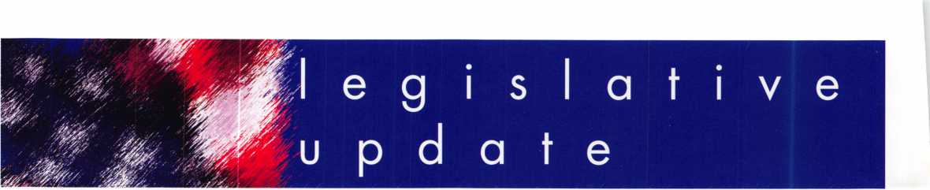

ALABAMA H537 AUTHOR: Martin (D) TITLE: Alarm System Licensure DISPOSITION: To Governor SUMMARY:

Relates to alarm system Licensure.

STATUS:

* 01/31/2006 INTRO­DUCED.
* 01/31/2006 To HOUSE Committee on BOARDS AND COM­MISSIONS.
* 03/02/2006 From HOUSE Committee on BOARDS AND COM­MISSIONS: Reported with substitute.
* 03/29/2006 BOARDS AND COMMISSIONS Committee substitute offered on HOUSE floor.
* 03/29/2006 BOARDS AND COMMISSIONS Committee substitute adopted on HOUSE floor.
* 03/29/2006 Passed HOUSE. *****fo SENATE.
* 03/29/2006 To SEN­ATE Committee on JUDICIARY.
* 04/04/2006 From SENATE Committee on JUDICIARY: Reported favorably with amend­ment.
* 04/17/2006 JUDICIA­RY Committee amend­ment offered on SEN­ATE floor.
* 04/17/2006 JUDICIA­RY Committee amend­ment adopted on SEN­ATE floor.
* 04/17/2006 Passed SENATE. *****f0 HOUSE for concur­rence.
* 04/17/2006 HOUSE concurred in SENATE amendments.
* 04/18/2006 To GOV­ERNOR.

CALIFORNIA SI542 AUTHOR: Migden (D) TITLE: Motor Vehicles:

Key Information Access DISPOSITION: Pending LOCATION: Senate Transportation and Housing Committee SUMMARY:

Requires a motor vehicle manufacturer of a motor vehicle sold or leased in this state with a model- year of 2008 or later, to rovide a means where- v the registered owner of that motor vehicle can access information, and only that information, that is necessary to permit the reproduction of a key or other functionally similar device, or the perform­ance of any necessary service, that will allow the registered vehicle's owner to enter, start, and operate his or her vehi­cle.

STATUS:

* 03/09/2006 To SEN­ATE Committee on TRANSPORTATION AND HOUSING.
* 04/18/2006 From SENATE Committee on TRANSPORTATION AND HOUSING: Do pass to Committee on RULES.

IOWA HS 507 SPONSOR: House Judiciary Committee TITLE: Locksmith Positive ID

DISPOSITION: Pending SUMMARY: Relates to a locksmith assisting a per­son in entering a residen­cy and providing a penalty.

STATUS:

* 01/10/2006 INTRO­DUCED.
* 01/10/2006 To HOUSE Committee on JUDICIARY.

ILLINOIS H 4616 SPONSOR: Saviano (R) TITLE: Firearm Authorization Card DISPOSITION: Pending

SUMMARY:

Amends the Private Detective, Private Alarm, Private Security, and Locksmith Act of 2004. Replaces references to firearm authorization card with firearm control card throughout the Act. Removes the provision that allows a person who meets certain qualifica­tions to receive a license as a private alarm con­tractor without having passed the required examination. Provides that the Department may issue a temporary firearm control card.

STATUS:

* 01/12/2006 INTRO­DUCED.
* 01/12/2006 To HOUSE Committee on RULES.

ILLINOIS H 4715 SPONSOR: Kelly (D) TITLE: Safe Homes Act DISPOSITION: Pending SUMMARY:

Creates the Safe Homes Act. Provides that a vic­tim of domestic violence or sexual violence has certain rights with respect to the victim's dwelling unit. Provides that, depending upon the cir­cumstances, the victim can obtain relief that includes: requiring that the landlord change the locks, allowing the victim to change the locks if the landlora does not act, ter­minating the lease, and imposing penalties on a landlora for certain viola­tions.

STATUS:

* 01/12/2006 INTRO­DUCED.
* 01/12/2006 To HOUSE Committee on HOUSING & URBAN DEVELOPMENT
* 01/12/2006 To HOUSE Committee on RULES.
* 02/14/2006 From

HOUSE Committee on HOUSING & URBAN DEVELOPMENT: Do pass. Adopted Amendment No. 1.

* 03/01/2006 From HOUSE Committee on RULES: Approved for Consideration- Amendment No. 2.
* 03/02/2006 In HOUSE. Read third time. Passed HOUSE. *****To SENATE.
* 03/07/2006 To SEN­ATE Committee on RULES.
* 03/08/2006 To SEN­ATE Committee on JUDICIARY
* 04/06/2006 In SEN­ATE. Read third time. Passed SENATE. *****To HOUSE for concurrence.

LOUISIANA HI055 AUTHOR: Pinac (D)

TITLE: Public Safety Department

DISPOSITION: Pending SUMMARY:

Creates the Life Safety and Property Protection Licensing Act; provides that the fire marshal is authorized to cause the inspection and testing of all life safety systems and equipment in tne state.

* 03/27/2006 INTRO­DUCED.
* 03/27/2006 To HOUSE

Committee on COM­MERCE.

MARYLAND S452 AUTHOR: Hooper (R) TITLE: Vehicle Laws DISPOSITION: Failed-Adjourned SUMMARY:

Requires a vehicle manu­facturer licensed in the State to implement, by January 1, 2008, a sys­tem to provide a regis­tered owner or lessee of a specified motor vehicle access to information suf­

ficient to allow the repro­duction of a key required to operate the motor vehi­cle; requires a manufac­turer to

allow access to this infor­mation 24 hours per day and 7 days per week. STATUS:

* 02/02/2006 INTRO­DUCED.
* 02/02/2006 To SEN­ATE Committee on JUDICIAL PROCEED­INGS.
* 03/14/2006 From SENATE Committee on JUDICIAL PROCEED­INGS: Reported unfa­vorably.

MARYLAND H 50 AUTHOR: Goodwin (D) TITLE: Business Income Tax Exemption for Security

DISPOSITION: Failed-

Adjourned

SUMMARY:

Allowing certain business entities a certain credit against the State income tax for certain expenses incurred for certain secu­rity devices and certain security guard services under certain circum­stances; limits to a certain amount the total amount of credits a business enti­ty may claim in any cal­endar year; provides that the credit may not exceed the State income tax for that taxable year and that any unused credit may not be carried over to any other taxable year.

STATUS:

* 01/03/2006 PRE­FILED.
* 01/1 1/2006 INTRO­DUCED.
* 01/1 1/2006 To HOUSE Committee on WAYS AND MEANS.
* 03/25/2006 From HOUSE Committee on WAYS AND MEANS: Reported as amended.
* 03/25/2006

40

Keynotes • May 2006



Committee amendment adopted on HOUSE floor.

* 03/27/2006 Passed HOUSE. *****To SENATE.
* 03/27/2006 To SEN­ATE Committee on BUDGET AND TAXA­TION.

MARYLAND H 667

AUTHOR: Boschert (R) TITLE: Maryland Locksmiths Act DISPOSITION: Failed- Adjourned SUMMARY:

Requires persons to be licensed by the Secretary of Labor, Licensing, and Regulation before a per­son may provide lock­smith services; requires the Secretary to adopt regulations for the licen­sure and regulation of locksmiths; providing that the Act does not limit the rights of specified individ­uals to engage in lock­smith services; provides for the powers and duties of the Secretary in licens­ing and regulating lock­smiths.

STATUS:

* 02/02/2006 INTRO­DUCED.
* 02/02/2006 To HOUSE Committee on ECONOMIC MAT­TERS.

MISSISSIPPI H 160

AUTHOR: Denny (R)

TITLE: Income Tax INTRODUCED: 02/02/2006 DISPOSITION: Failed SUMMARY:

Relates to income tax; provides credit for tax­payer paying home secu­rity expenses for primary residence.

STATUS:

* 01/03/2006 INTRO­DUCED.
* 01/03/2006 To

HOUSE Committee on WAYS AND MEANS.

MISSISSIPPI S 2484

AUTHOR: Jackson G (R) TITLE: Alarm Contractors Licensing Act DISPOSITION: Failed SUMMARY:

Relates to the state Alarm Contractors Licensing Act.

STATUS:

* 01/12/2006 INTRO­DUCED.
* 01/12/2006 To SEN­ATE Committee on BUSINESS AND FINANCIAL INSTITU­TIONS.
* 01/31/2006 Died in committee.

OKLAHOAAA S 1741

AUTHOR: Barrington (R) TITLE: Professions And Occupations DISPOSITION: Pending SUMMARY:

Relates to professions and occupations; relate to the Alarm Industry Act; provides short title; adds the locksmith industry to create the Alarm ana Locksmith Industry Act; adds definitions; makes language gender neutral; provides exemptions; pro­vides exemption from cer­tain Act; provides for the Alarm and Locksmith Industry Committee; mod­ifies membership, experi­ence and terms of the Committee; provides for powers and duties of the Committee.

STATUS:

* 01/20/2006 PRE­FILED.
* 02/06/2006 INTRO­DUCED.
* 02/07/2006 To SEN­ATE Committee on BUSINESS AND LABOR.
* 02/28/2006 From SENATE Committee on BUSINESS AND LABOR: Do pass as

amended.

* 03/09/2006 Passed SENATE. *****fo HOUSE.
* 03/16/2006 To HOUSE Committee on COMMERCE, INDUS­TRY AND LABOR.
* 04/06/2006 From HOUSE Committee on COMMERCE, INDUS­TRY AND LABOR: Do pass.
* 4/20/2006 Third Reading, Measure passed
* 4/20/2006 Referred for enrollment

OHIO H527

AUTHOR: Uecker (R) TITLE: Security System Company Licensure DISPOSITION: Pending SUMMARY:

Requires the licensure of security systems compa­nies; provides for the reg­istration of individuals performing specified types of work related to security systems; provides for the regulation of secu­rity systems companies and employees; establish­es the Security Systems Advisory Board in the Department of Public Safety.

STATUS:

* 03/07/2006 INTRO­DUCED.
* 03/07/2006 To HOUSE Committee on RULES AND REFER­ENCE.
* 03/09/2006 From HOUSE Committee on RULES AND REFER­ENCE: Recommended referral.
* 03/09/2006 To HOUSE Committee on TRANSPORTATION, PUBLIC SAFETY, AND HOMELAND SECURI­TY.

TENNESSEE HI731 (Same As TN S2024)

AUTHOR: Maddox (D) TITLE: Locksmith Licensing

DISPOSITION: Pending (Carryover from 2005) SUMMARY:

Concerns Licenses; requires locksmiths to be licensed; such licenses to be obtained from the commissioner of com­merce and insurance. STATUS:

* 02/16/2005 INTRO­DUCED.
* 05/03/2005 In HOUSE Committee on COMMERCE: Subcommittee on INDUSTRIAL IMPACT recommend passage.
* 03/01/2006 Placed on calendar in HOUSE Committee on COM­MERCE for 3/7/2006
* 03/07/2006 Action Deferred in HOUSE Committee on COM­MERCE to 3/28/2006
* 03/28/2006 Action Deferred in HOUSE Committee on COM­MERCE to 4/11/2006
* 04/11/2006 Action Deferred in HOUSE Committee on COM­MERCE to 4/25/2006

VIRGINIA S 125

AUTHOR: O'Brien (R) TITLE: Motor Vehicle Keys DISPOSITION: Pending SUMMARY:

Requires a means where­by the owners, lessees, and representatives of owners and lessees of such motor vehicles may obtain all information required to permit the reproduction of any key required to operate the owner's or lessee's vehi­cle.

STATUS:

* 01/11/2006 INTRO­DUCED.
* 01/11/2006 To SEN­ATE Committee on TRANSPORTATION.
* 01/19/2006 In SEN­ATE Committee: Postponed indefinitely.

WASHINGTON S 6296

AUTHOR: Delvin (R)

TITLE: Alarm System

Companies

DISPOSITION:

Failed-Adjourned

SUMMARY:

Relates to alarm system companies and licensing of private security guards.

STATUS:

* 01/10/2006 INTRO­DUCED.
* 01/10/2006 To SEN­ATE Committee on LABOR, COMMERCE, RESEARCH & DEVEL­OPMENT.

WEST VIRGINIA H 3177

AUTHOR: Talbott (D)

TITLE: Home Security System Installers DISPOSITION: Failed-Adjourned SUMMARY:

Requires that employers erform criminal history ackground checks for employees involved in the installation of home secu­rity systems.

STATUS:

* 01/1 1/2006 INTRO­DUCED.
* 01/1 1/2006 To HOUSE Committee on JUDICIARY.

US CONGRESS H3632

AUTHOR: LaTourette (R) TITLE: Electronic Premise Security Systems DISPOSITION: Pending SUMMARY:

Allows a deduction for expenses related to the purchase and installation of qualifying electronic premise security systems. STATUS:

* 07/29/2005 INTRO­DUCED.
* 07/29/2005 To HOUSE Committee on WAYS AND MEANS.



Keynotes • May 2006

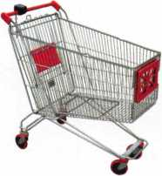

keynotes

**Buyer's Marketplace**

IN-STOCK...MORE SAFES

***FREE Freight Program***

***(30 States)***

AMSBC FireKing  
fiartall HAYMAN  
MEILINK ytCTOR.

TURD tO

**WHOLESALE SERVICE**

800-848-9790

ACCEPT CREDIT CARDS!

In your Locksmithing Business,

Storefronts/Offices/Homebased

Businesses#®

**No application fees*

**No Monthly Minimum*

**No Lease Requirements**

**Onsite wireless terminals available**

RETRIEVER PAYMENT SYSTEMS

888-549-6424

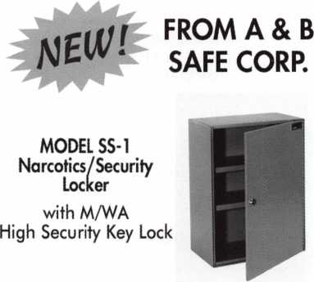

A & B SAFE CORPORATION

114 S. Delsea Drive, Suite 3  
Glassboro, NJ 08028-6237  
856-863-1186 Fax 856-863-1208

i

Keynotes • April 2006

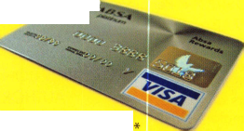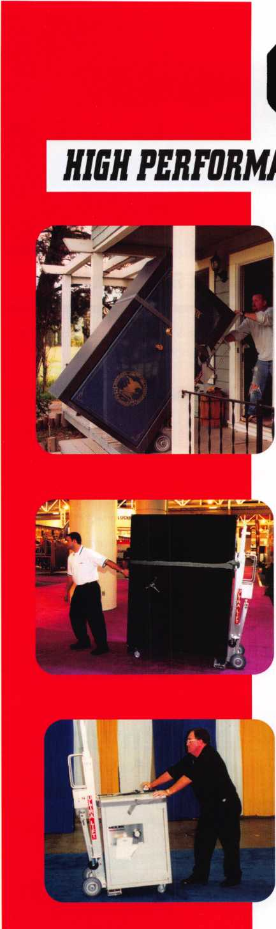

***OPERATOR SAFETY***

Injuries can be virtually eliminated. Ultra Lift does the lift-  
ing so that operator effort required to complete a move is  
minimized. Heavy loads are broken back with ease. The  
operator stays in control by using a combination of motor  
power, balance and leverage in every phase of a move.

***REDUCE LABOR COSTS***

Fewer people are required for any move with Ultra Lift.  
Manpower can be scheduled more productively. Labor  
savings often pay for the Ultra Lift in one month.

***ELIMINATE DAMAGE***

Loads are broken back, set down and moved under power  
with maximum leverage and operator control. Gentle  
handling eliminates bumps, bounces and damage to the  
load and premises.

***INCREASE PROFITS***

Increased operator safety, reduced labor cost and elimina-  
tion of damage to the load and premises all contribute to  
significant increases in profits.

FOR LITERATURE, VIDEO OR ON-SITE  
DEMONSTRATION, WRITE OR CALL:

ULTRA LIFT CORPORATION

475 STOCKTON AVENUE, UNIT E  
SAN JOSE, CA 95126  
800-346-3057  
408-287-9400  
FAX 408-297-1199  
E-mail: [info@uitraHft.com](mailto:info@uitraHft.com)  
[www.ultralift.com](http://www.ultralift.com)

ULTRA LIFT supplies the power - so you don't have  
to. One person can safely and easily handle loads  
that usually require 2 or 3 people, even up or down  
stairs. Two people can handle most safes to 1500  
pounds. If safety is your concern, ULTRA LIFT is the  
best move you'll ever make!

**U.S. PATENT 4.570.953**

**2 Million Customers**

at Your Fingertips

tatemet Shoppers are looking for a locksmith Right Howl

ALOA Partners with ServiceMagic® to give members discounted access to leading online marketing solution. Through the  
relationship, our members will now have access to ServiceMagic's online marketing solution that can dramatically

increase revenue and profits.

As an ALOA member, you can now receive targeted cus-  
tomer leads from consumers looking for a locksmith in  
your area through ServiceMagic. The program gives you  
immediate access to ready-to-buy consumers.



* Increase Your Customer Reach - ServiceMagic gets you access to more than 2 million unique visitors and more than 150,000 consumer leads each month.
* Target Your Leads - Get matched consumers looking for locksmiths in only the locations you want to work.
* Increase Your Profits - Service Professionals who have used ServiceMagic for at least a year report grow­ing their business by 28% on average. Many report that ServiceMagic has become their lowest-cost form of advertising.

Free Enrollment Fee for a Limited Time - On behalf of the Associated Locksmiths of America,

save $99 by enrolling now.

Unlike other marketing initiatives, with ServiceMagic there are no long-term contracts or ongoing monthly or annual fees. Once in, you pay only for the targeted customer leads you receive. To learn more, please visit: [www.servicemagic.com/ext/771036](http://www.servicemagic.com/ext/771036)

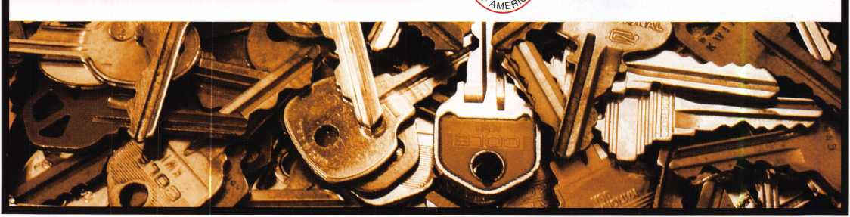

**To learn more, visit**

**<http://www.servicemagic.com/ext/771036>  
or call 888.528.9179**

SERVICE

A G I C

.com

I

i

**Adesco FireKing/Gary Meilink**

t/bR **safes that fit every need and budget, count on the trusted**

BRANDS OF FlREKlNG® SECURITY GROUP. ADESCO® OFFERS SAFES FOR GOVERNMENT, COMMERCIAL AND RESIDENTIAL CUSTOMERS. MEILINK® PROVIDES FIRE- AND B U RG L ARY-RAT E D SAFES FOR BANKS, SCHOOLS AND RETAIL ESTABLISHMENTS. AND FlREKlNG FEATURES UL®-RATED FIRE/ IMPACT/BURGLARY RESISTANT SAFES BACKED BY OVER 50 YEARS OF SECURITY EXPERIENCE. PLUS, EACH BRAND COMES WITH EXCLUSIVE 24/7/365 TECHNICAL SUPPORT. SO FIND OUT MORE ABOUT FlREKlNG SECURITY GROUP. YOUR CUSTOMERS TRUST YOU TO RECOMMEND THE BEST. TRUST US TO PROVIDE IT.

a/ SOO-4S7-2424

( **FireKing**

SECURITY GROUP w

[www.fireking.com](http://www.fireking.com)

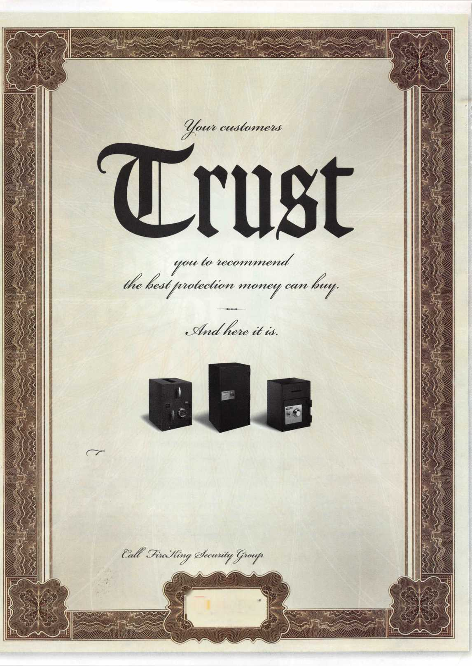

Raymond, 4 years Accounting

We represent the 500 employees  
of CompX Security Products.

Hardworking. Reliable. Dedicated.

And it shows in the products we make.

Is it any surprise that, year after year, you

community, choose to partner with us?

Made in America does matter to you, and

it matters to us.

Through our four US facilities, we will continue to provide  
you with the high quality products you have come to expect  
from CompX Security Products.

***Cbm®C,***

SECURITY PRODUCTS

y, 8 years tomer Service ^

*Cbm®C*

Alberto, 11 years Machine Operator

*Cbm*®(

Shirley, 23 years Lock Assembly

*Cbm*®(

*Cbm®Z*

NATIONAL

FORT TIMBERLINE

CHICAGO

